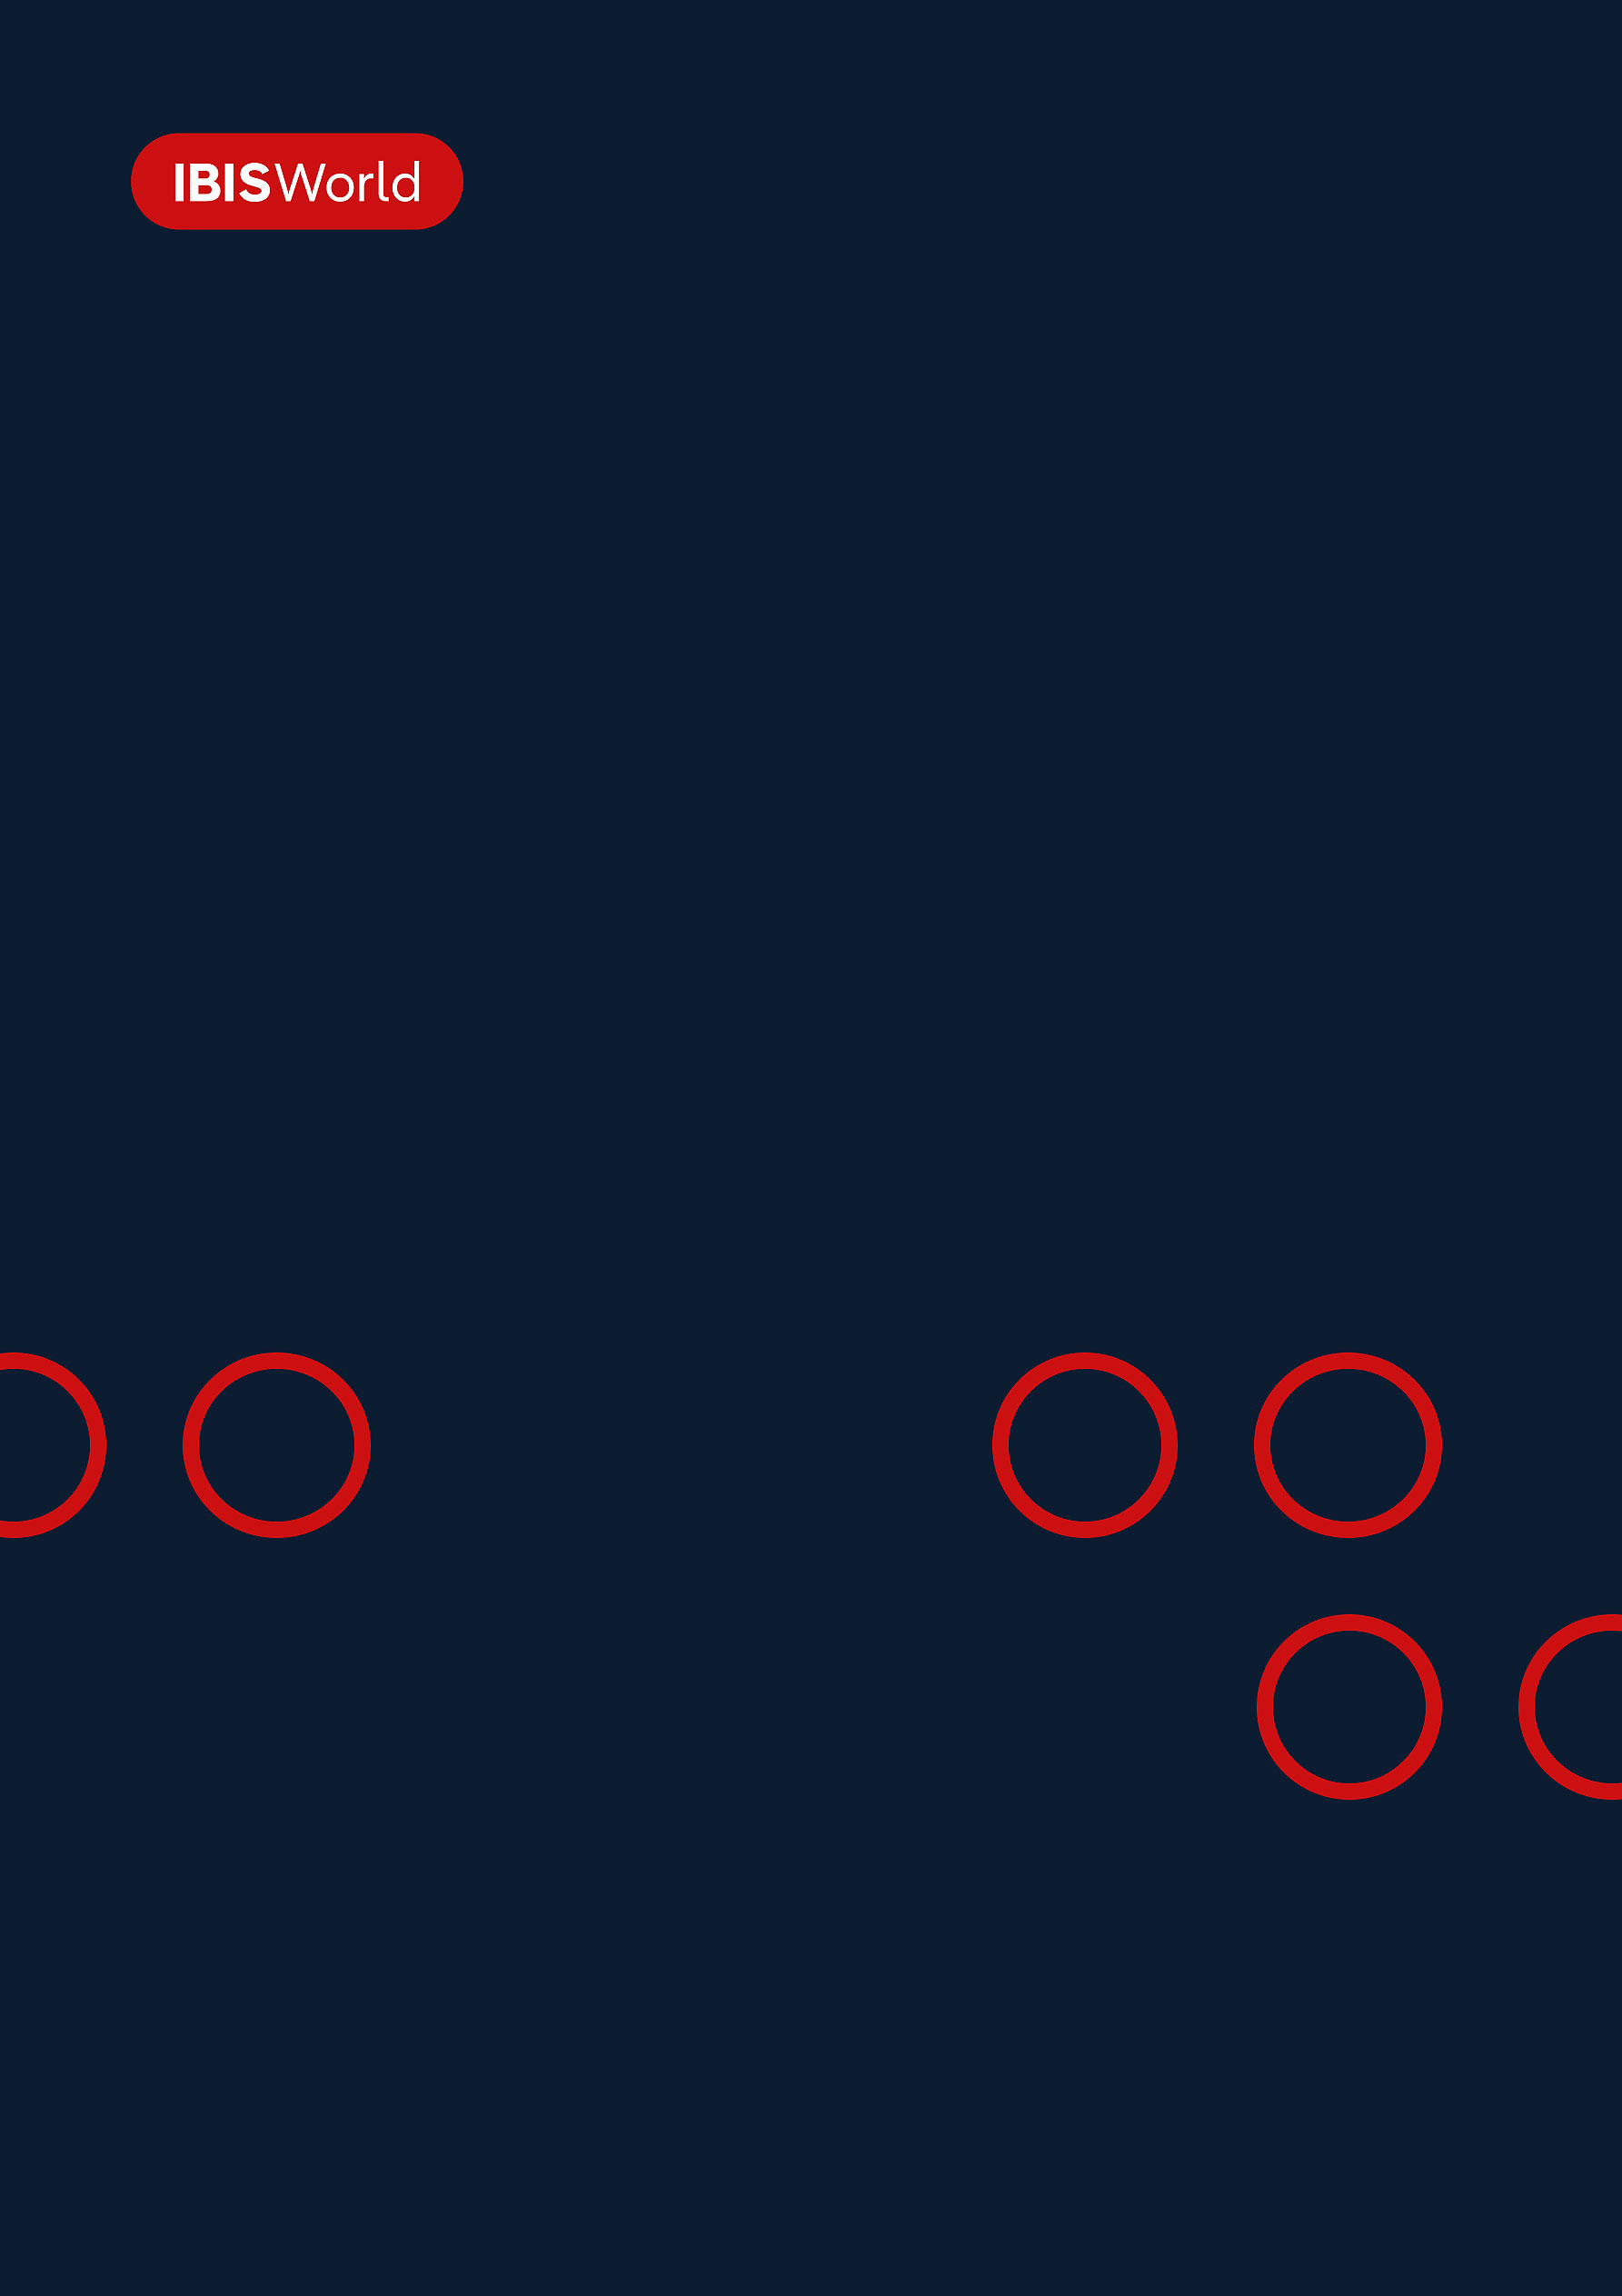
INDUSTRY REPORT
Commodity Contracts Intermediation in the US
Apr 2026

About

IBISWorld
IBISWorld specializes in industry research with coverage on thousands of global industries. Our comprehensive data and in-depth analysis help businesses of all types gain quick and actionable insights on industries around the world. Busy professionals can spend less time researching and preparing for meetings, and more time focused on making strategic business decisions.

Table Of Contents | Standard

1. About 4
Codes 4
Definition 4
Related Terms 4
What's Included 4
Related Industries 5
Additional Resources 5
2. At a Glance 6
Key Takeaways 6
Products and Services 7
Major Players 8
Key External Drivers 9
Industry Structure 9
SWOT 10
Executive Summary 10
3. Performance 12
Highlights 12
Key Takeaways 12
Performance Snapshot 13
Outlook 21
Life Cycle 23
4. Products and Markets 24
Key Takeaways 24
Products and Services 24
Major Markets 28
International Trade 30
5. Geographic Breakdown 31
Key Takeaways 31
Business Locations 32
6. Competitive Forces 40
Key Takeaways 40
Concentration 40
Barriers to Entry 41
Substitutes 42
Buyer & Supplier Power 43
7. Companies 45
8. External Environment 46
Key Takeaways 46
External Drivers 46
Regulation & Policy 49
Assistance 50
9. Financial Benchmarks 51
Key Takeaways 51
Cost Structure 51
Financial Ratios 55
Valuation Multiples 61
Key Ratios 62
10. Key Statistics 64
Industry Data 64

1. About
https://my.ibisworld.com/us/en/industry/52316/about

Codes
NAICS 2017 - USA | 52313
NAICS 2017 - USA | 523130
NAICS 2022 - USA | 52316
NAICS 2022 - USA | 523160

Definition
This industry includes operators and individuals that trade commodity derivatives. Commodity derivatives, such as futures, forwards, swaps and options, are financial securities that offer returns based on the return of an underlying commodity, such as agricultural products, energy resources and foreign currency. Brokers execute buyers’ orders by arranging transactions on a commission or transaction-fee basis, while dealers buy and sell derivatives on their own accounts for profit.

Related Terms

ASSETS UNDER MANAGEMENT (AUM)
The value of financial assets managed by a portfolio manager or financial institution on behalf of investors.

FINANCIAL ASSETS
Nonphysical assets such as shares, bonds, notes and bank balances.

COMMODITIES CONTRACTS
Agreements to buy a predetermined good, such as steel, corn, wheat, oil and gold, at a specific price and date in the future.

EXCHANGE-TRADED FUNDS (ETFS)
An investment fund that tracks multiple securities that is traded on an exchange, like an individual stock.

OVER-THE-COUNTER (OTC)
A security traded in some context other than on a formal exchange, such as derivatives, which can be traded through a dealer network.

What's Included
- Exchange traded futures
- Exchange traded options
- Trading derivatives on own account
- OTC options
- Other OTC derivatives
- Trading currency/other commodity contracts
- Investment management
- Commodity options contracts

Related Industries

Industries in the Same Sector
- Competitors:
  - Investment Banking & Securities Dealing in the US
- Complementors:
  - Securities Brokering in the US

International Industries
- No data available

Additional Resources
- Bank for International Settlements
- Commodity Online
- Food and Agriculture Organization of the United Nations
- Securities Industry and Financial Markets Association
- US Census Bureau

2. At a Glance
https://my.ibisworld.com/us/en/industry/52316/at-a-glance
Revenue  $22.3bn  ’21-’26 ↑ 0.8 %  ’26-’31 ↑ 0.4 % | Employees  28,433  ’21-’26 ↑ 3.6 %  ’26-’31 ↑ 1.5 % | Businesses  6,220  ’21-’26 ↓ 6.5 %  ’26-’31 ↑ 2.2 %
Profit  $1.5bn  ’21-’26 ↓ 6.4 % | Profit Margin  6.9%  ’21-’26 ↓ 3.1 pp | Wages  $8.4bn  ’21-’26 ↑ 9.8 %  ’26-’31 ↑ 1.2 %

Key Takeaways

Performance
- Heightened economic uncertainty and commodity price volatility increase broker demand. Higher speculation on commodity prices and geopolitical instability in the Middle East, for example stemming from the conflict with Iran, impact oil prices.
- Weakening US dollar and commodity prices is poised to reverse growth. Although automated technology will enhance broker efficiency, anticipated price declines across core commodities will curtail long-term commodity investment appeal.

Products and Markets
- The growing popularity of commodities across major brokerages enhances market diversification. Futures contracts are traded on a futures exchange, although some major brokerages incorporate commodity trades into their service offering.
- Commodity contracts effectively hedge against price fluctuations. These financial tools mitigate investment risks, safeguarding both against potential losses and preserving profits in volatile market conditions.

Products and Services
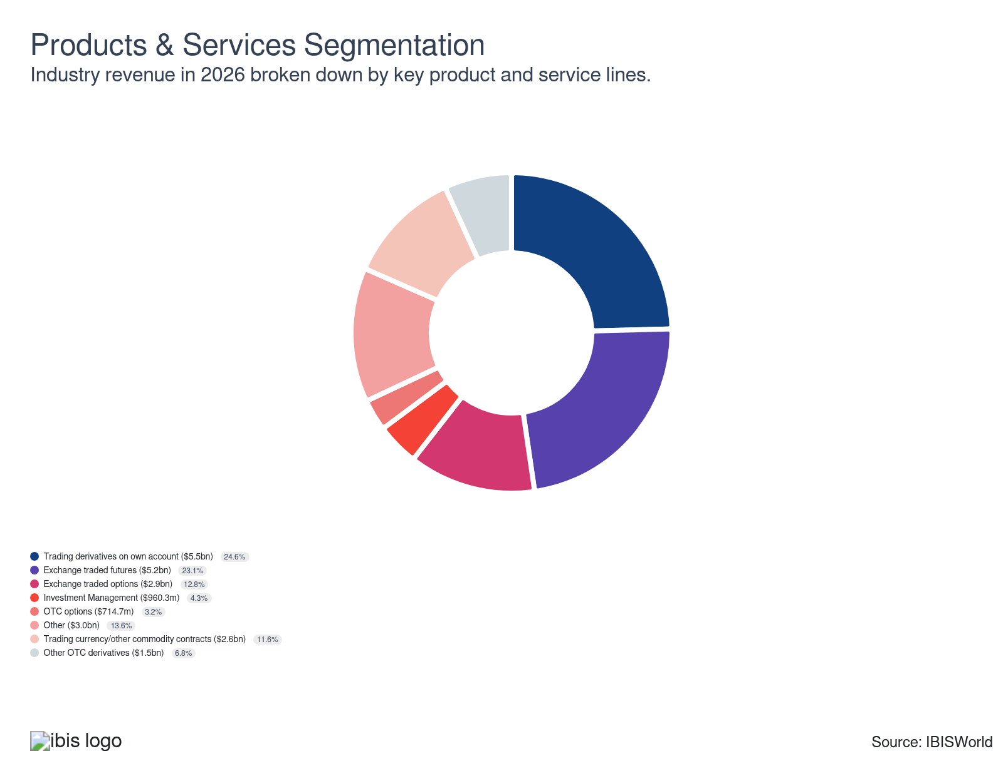

Major Players
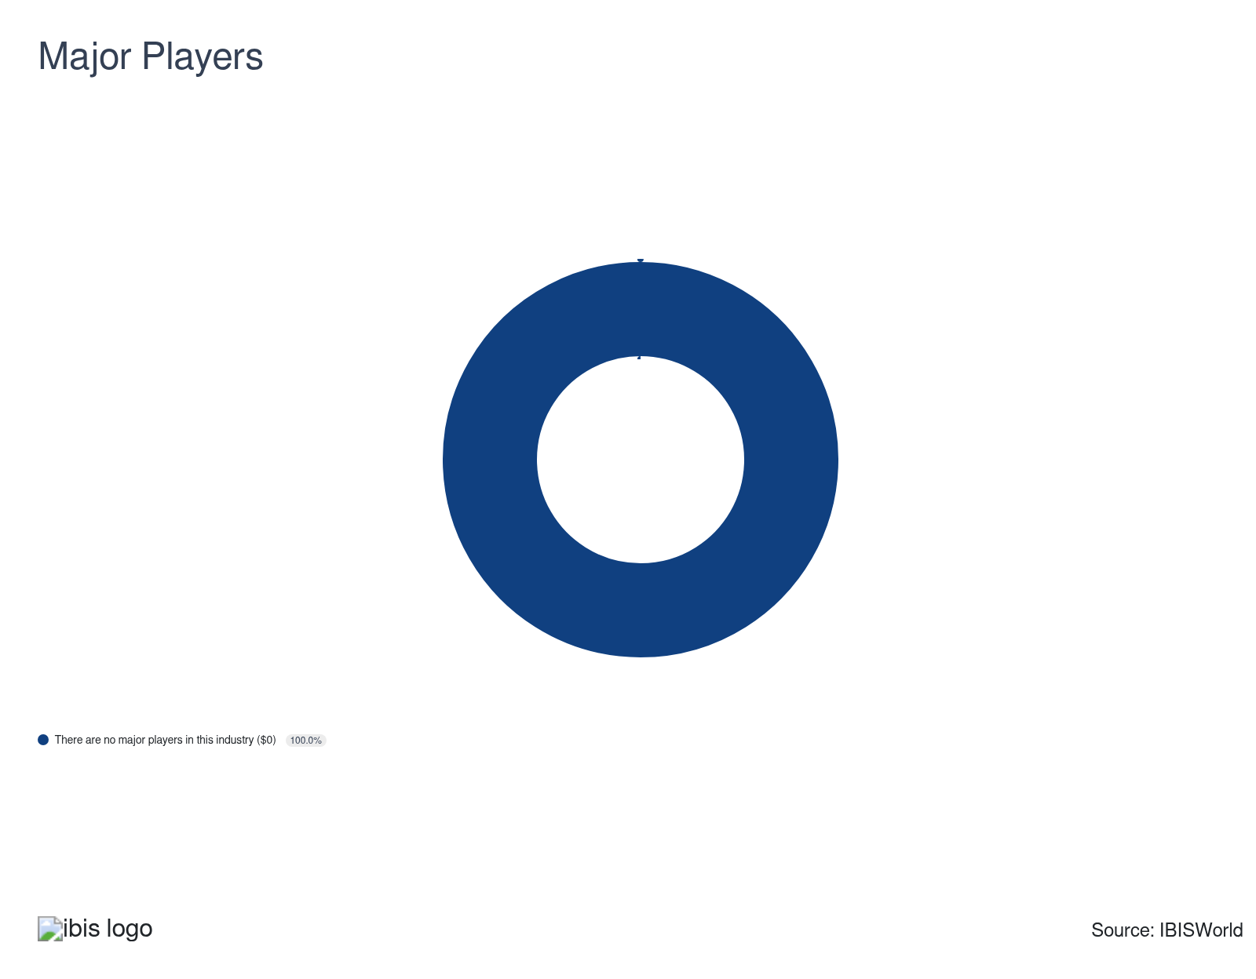

Key External Drivers
Key External Drivers | Impact
World GDP | Positive
World price of crude oil | Positive
Agricultural price index | Positive
Trade-weighted index | Positive

Industry Structure
Characteristic | Level | Trend
Concentration | Low
Barriers To Entry | Moderate | Steady
Regulation and Policy | High | Increasing
Life Cycle | Mature
Revenue Volatility | Moderate
Assistance | None | Steady
Competition | High | Increasing
Innovation | Moderate

SWOT
Strengths  Low Imports  Low Customer Class Concentration  Low Product/Service Concentration  Low Capital Requirements | Weaknesses  None & Steady Level of Assistance  High Competition  Low Profit vs. Sector Average  Low Revenue per Employee | Opportunities  High Revenue Growth (2020-2025)  High Revenue Growth (2025-2030)  World GDP | Threats  Low Revenue Growth (2005-2025)  Low Outlier Growth  Low Performance Drivers  World price of crude oil

Executive Summary

Brokered down: Increased demand for metal and energy products and global commodity volatility will sustain growth
High price volatility among various commodities and the lowering of interest rates in the latter part of the period have fueled strong growth among commodity contracts intermediation brokers. While the national economy continued to recover after a period of high inflationary pressures in the middle of the current period, rate cuts by the Federal Reserve in 2024 and 2025 – in addition to continued price volatility of oil and agricultural products – strengthened commodity contracts’ popularity. During the current period, particularly in 2022, the industry experienced a significant jump in the world price of crude oil. Although the price receded from record highs since, volatility persisted. The conflict with Iran has returned oil prices to above $100 per barrel and limited oil supply out of the Middle East, significantly impacting commodity contracts and furthering volatility. For example, the world price of crude oil is anticipated to climb 14.5% in 2026 alone. However, the recently announced ceasefire in the Iran conflict limited oil price volatility, although oil prices still remain substantially elevated. Short-term contracts and futures continue to facilitate interest among brokers, with revenue growing at a CAGR of 0.8% to $22.3 billion over the past five years, including an estimated increase of 4.8% in the current year alone. Profit declined during the period and is projected to equal a 6.9% share of revenue in the current year.
Banks were forced to limit proprietary trading due to the Volcker rule, enacted prior to the current period in 2010 after the financial crisis. This resulted in banks significantly downsizing or completely ending their commodity trading activities. The decreased presence of banks in this industry, in which they were once outsized players, allowed smaller players to enter the industry and exacerbated fragmentation among various service groups. However, industry establishments fell, highlighting the mergers in the industry as operators seek to better compete against external competition like banks. The inflationary spike during the current period played a key role in buoying growth, with geopolitical conflicts in the Middle East and Europe driving commodity price volatility and fueling the growth in the world price of crude oil.
Moving forward, commodity contract intermediaries face a less certain landscape, as the anticipation of slight declines in global oil prices will dampen the popularity of long-term commodity trades. Limited demand for metal and energy products and the low inventories of metal commodities are expected to limit revenue gains for brokers. In addition, further uncertainty surrounding the geopolitical landscape, such as conflicts and trade wars, will impact the types of trades made by commodity traders. Greater automation and the adoption of new technologies, such as blockchain, will enhance workflows in the longer term. Overall, industry revenue is anticipated to inch upward at a CAGR of 0.4% to an estimated $22.7 billion over the next five years.

3. Performance
https://my.ibisworld.com/us/en/industry/52316/performance

Highlights
Revenue  $22.3bn  2021-26 CAGR ↑ 0.8 %  2026-31 CAGR ↑ 0.4 % | Employees  28,433  2021-26 CAGR ↑ 3.6 %  2026-31 CAGR ↑ 1.5 % | Businesses  6,220  2021-26 CAGR ↓ 6.5 %  2026-31 CAGR ↑ 2.2 %
Profit  $1.5bn  2021-26 CAGR ↓ 6.4 % | Profit Margin  6.9%  2021-26 CAGR ↓ 3.1 pp

Key Takeaways
- Heightened economic uncertainty and commodity price volatility increase broker demand. Higher speculation on commodity prices and geopolitical instability in the Middle East, for example stemming from the conflict with Iran, impact oil prices.
- Weakening US dollar and commodity prices is poised to reverse growth. Although automated technology will enhance broker efficiency, anticipated price declines across core commodities will curtail long-term commodity investment appeal.

Performance Snapshot
Revenue: | ↑ 2021-26 Revenue CAGR +0.8%
Revenue  $22.3bn  ’21-’26 ↑ 0.8 %  ’26-’31 ↑ 0.4 % | 2026 Revenue Growth  ↑ 4.8 % | Revenue Volatility  Moderate
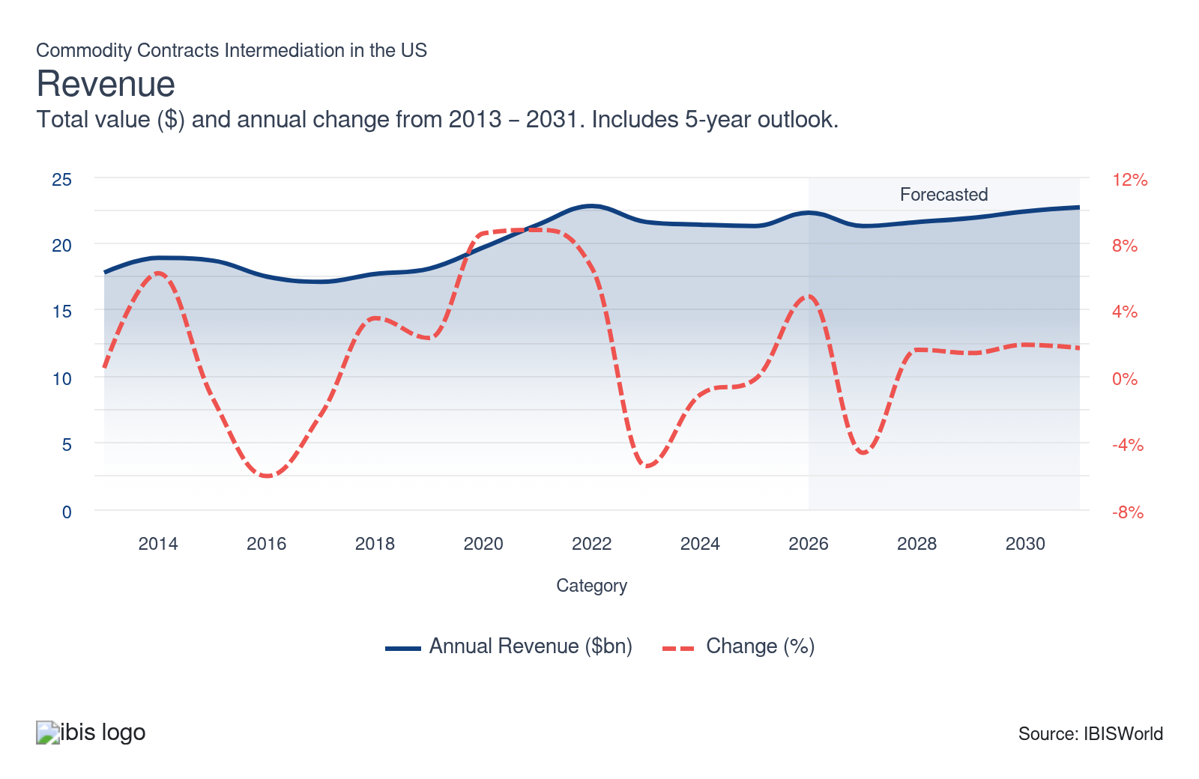
Employees: | ↑ 2021-26 Employees CAGR +3.6%
Employees  28,433  ’21-’26 ↑ 3.6 %  ’26-’31 ↑ 1.5 % | Employees per Business  5  ’21-’26 ↑ 10.9 %  ’26-’31 ↓ 0.8 % | Revenue per Employee  $785k  ’21-’26 ↓ 2.7 %  ’26-’31 ↓ 1.1 %
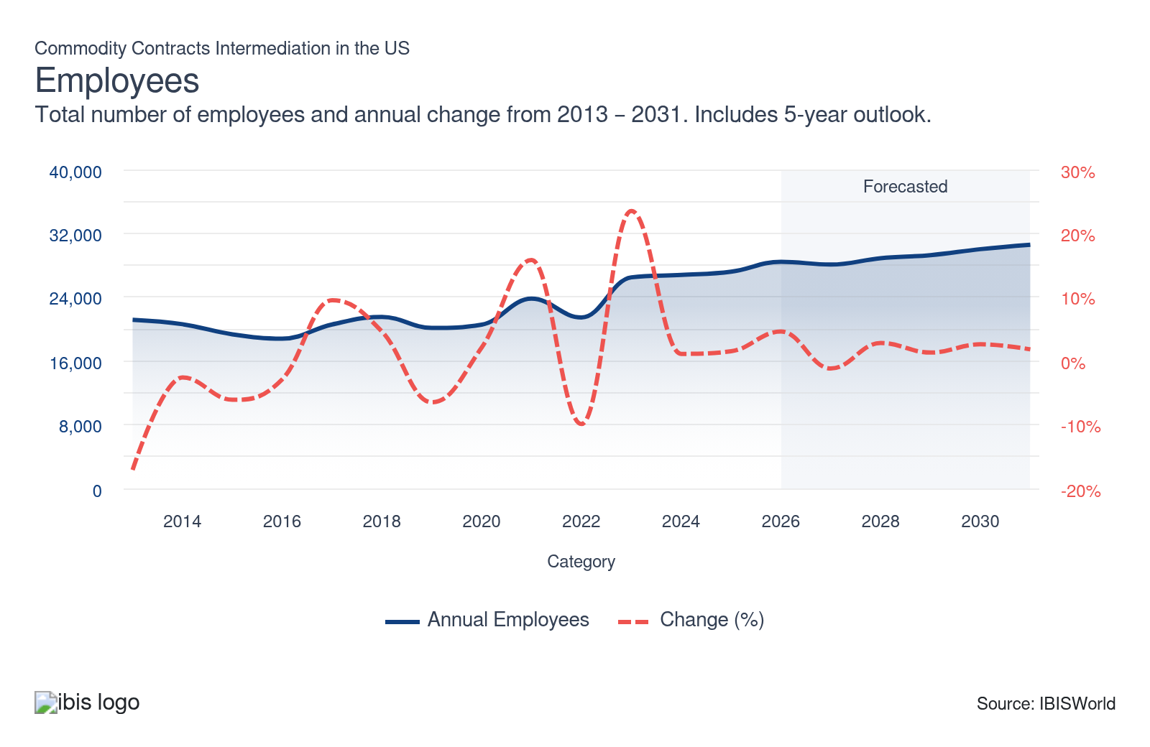
Businesses: | ↓ 2021-26 Business CAGR -6.5%
Businesses  6,220  ’21-’26 ↓ 6.5 %  ’26-’31 ↑ 2.2 % | Employees per Business  5  ’21-’26 ↑ 10.9 %  ’26-’31 ↓ 0.8 % | Revenue per Business  $3.6m  ’21-’26 ↑ 7.9 %  ’26-’31 ↓ 1.8 %
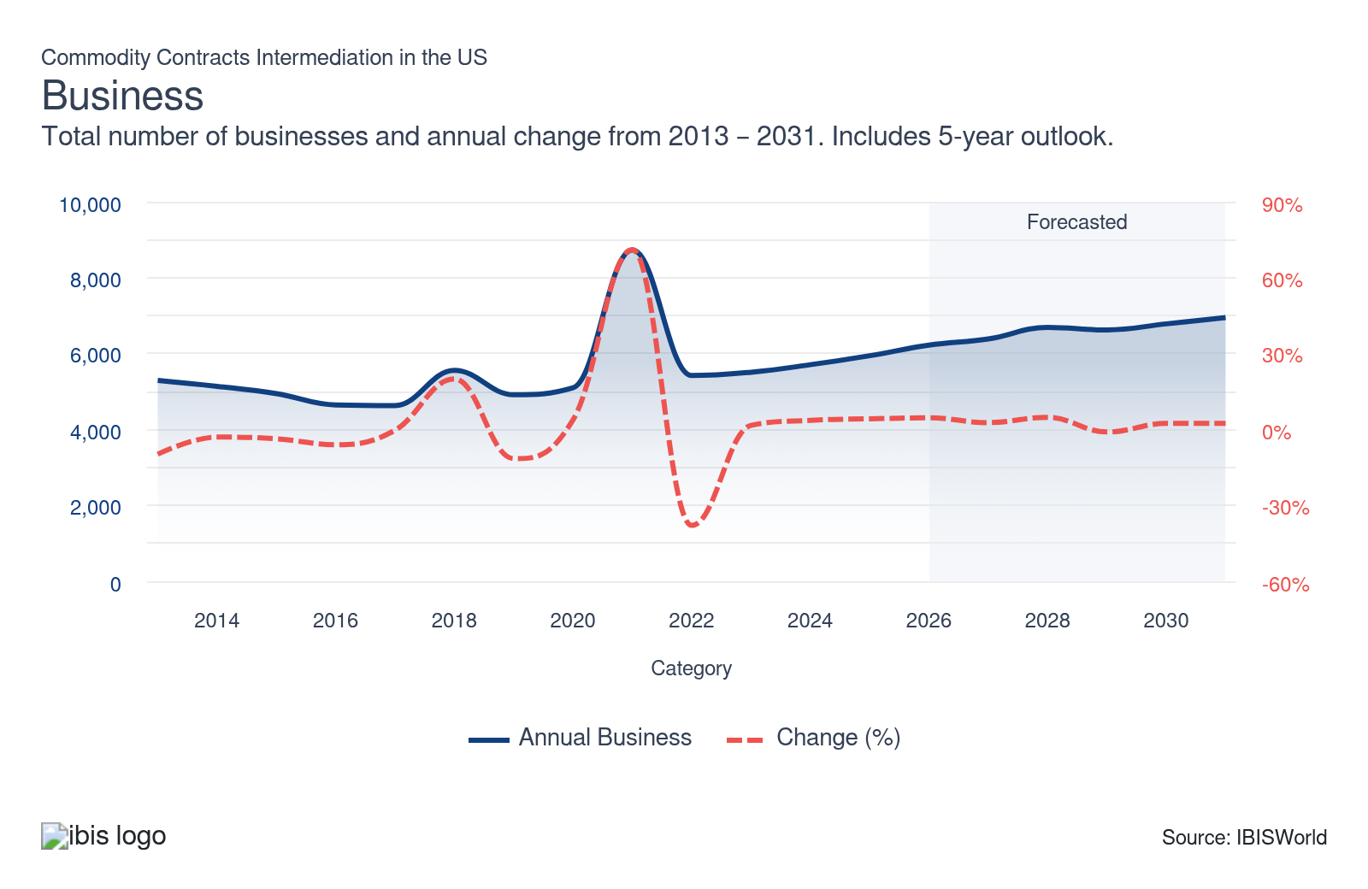
Profit: | ↓ 2021-26 Profit CAGR -6.4%
Total Profit  $1.5bn  ’21-’26 ↓ 6.4 % | Profit Margin  6.9%  ’21-’26 ↓ 3.1 pp | Profit per Business  $247.8k
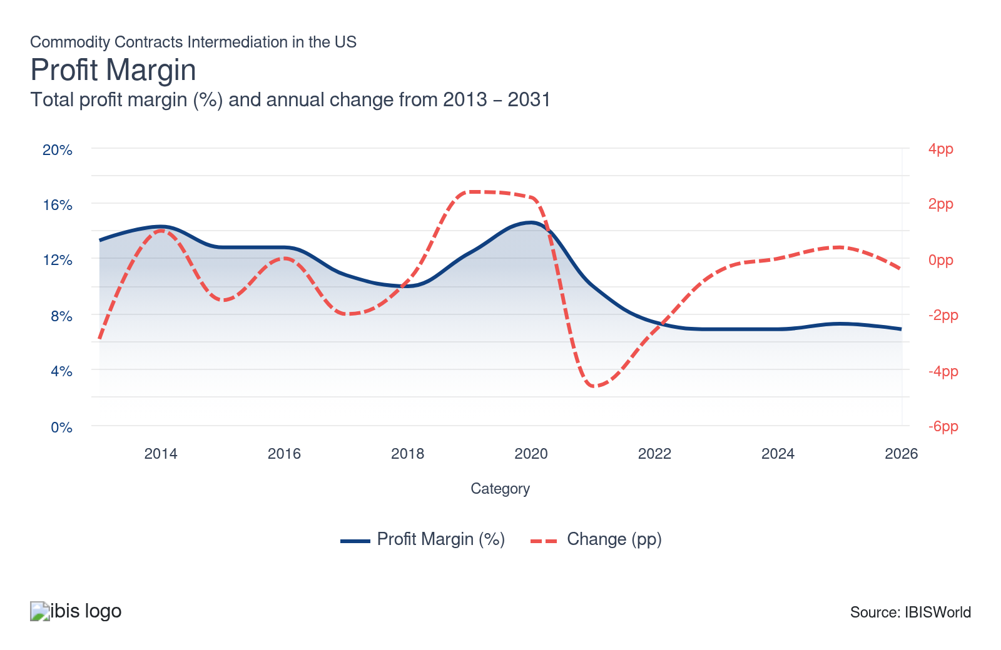
Current Performance
Current Performance

What's driving current industry performance?

Heightened interest rates and persistent inflation limit growth
- Although core commodities such as oil and agricultural products have bolstered commodity contract demand as the world price of oil experienced a significant increase during the period and the agriculture price index also climbed, although the continued effects of high interest rates in response to inflation curtailed liquidity in the financial markets via more expensive borrowing costs.
- The impact of inflationary pressures significantly impacted volatility of core commodities such as food items, with recent hikes in the agricultural price index. The price of food items have risen due to supply chain disruptions, extreme weather events and trade wars which have tightened the supply of various food, increasing their price. These rapid increases have dampened profitability of long-term commodity contracts.
- Nonetheless, in the latter part of the current period, slowdowns in natural gas prices, stemming from stabilization of downstream consumer demand and greater production output, have generated greater interest in put contracts and benefited short sellers. Despite natural gas prices falling in the latter part of the period, overall, these prices have climbed over the past five years.

Strengthening global demand and higher oil prices is a boon for commodity traders
- As economic conditions continue to strengthen following a period of high inflation, global demand for a swathe of commodities continues to facilitate growth. Higher consumer activity and demand for physical goods, such as smartphones, facilitated price hikes for nonferrous metals, such as aluminum and copper, which generated more lucrative derivative returns.
- According to the latest data from Reuters, OPEC+ announced the continuation of oil production cuts to the tune of 3.66 million bpd heading into 2025 in an attempt to increase global oil prices and compete with higher US oil production. Although, global oil prices have lagged in the latter part of the period.
- Energy producers faced disrupted supply chains and unpredictable demand, specifically at the onset of the period. Forward contracts and hedging strategies were increasingly used to manage uncertainty in delivery timelines, price forecasts and to manage oil inventories. Industry operators maintain higher caution in structuring supply-linked contracts, adjusting for persistent disruption risks.

Geopolitical tensions and trade conflicts continue to impact commodity prices
- The continued effects of multiple geopolitical conflicts accelerated uncertainty over commodity price stability, creating greater interest in riskier commodity contract trades. Tensions in the Middle East, coupled with the Ukraine-Russia war, have significantly impacted trade routes for commodities such as food and natural gas, with shipments now taking longer and becoming more expensive.
- Greater domestic output of oil and the potential for new contracts on commodities such as natural gas between the US and EU continues to facilitate lucrative commodity prices and trade opportunities. However, investors and traders adjusted commodity portfolios to hedge against unpredictable commodity flows. The complex delivery and inventory management of oil and gas has resulted in these commodity contracts becoming increasingly complex.
- Commodity contract intermediaries and global investors closely track disruptive events and the potential it has on various commodity classes. For example, trade wars, sanctions, regional unrest and supply chain blockages caused spikes in price volatility and risk premiums to certain contracts. Diversification in contract sourcing has become standard for most operators.

The industry has experienced growth in digitization
- Commodity contract intermediaries and technology providers spearheaded digital adoption during the period. Automated trading platforms and advanced analytics have enhanced contract execution and increased the overall volume of commodity contracts volumes. The efficiency of operations improved significantly, competition for tech talent heightened and smaller operators faced pressure to keep pace.
- Industry operators and risk managers deployed AI-enabled systems to improve price curve modeling and spot market anomalies. Predictive analytics and machine learning enhance risk assessment and customer segmentation, leading to more dynamic contract offerings. Industry companies have embraced these technologies in an effort to maintain profit while also becoming more competitive.
- Industry companies modified systems for micro-futures, fractional contracts and app-based clearing, which enabled customers to mitigate their exposure to long term risks by utilizing short term contracts. Also, new products became available to retail traders, fostering greater market accessibility and the growth in retail participation has boosted demand for industry services.

Geopolitical risks and the Middle East conflict fuel rising oil prices
- During the period, extreme crude oil price volatility and geopolitical shocks, including the conflict with Iran, materially reshaped risk-transfer flows in commodity contract intermediation. Countries in proximity to Iran, such as OPEC+ members in the Persian Gulf, experienced reduced oil exports, driving up the price of oil prices. This is driving crude oil prices higher and forcing oil producers and commodity contract intermediaries to hedge larger notional exposures and industry companies are adjusting to greater risk appetites and more dynamic limits to commodity trading.
- The conflict with Iran has threatened the Strait of Hormuz, raising geopolitical risk premiums in crude benchmarks and spreads. Markets are pricing the probability of supply disruption to roughly one-fifth of seaborne oil flows, heightening volatility in time-spreads and periodic dislocations between physical and paper markets. The volatility has shaken the industry and resulted in operators repricing risk and hedges. However, oil volatility has been reduced recently due to the announced ceasefire between the United States and Iran, bringing some stability to oil prices, although oil prices remain elevated.
- The crude oil complex is becoming more financialized, with macro and systematic funds using oil derivatives as proxies for inflation and growth. Large price swings and news of the conflict drive speculative trading and value strategies, raising volumes in commodity contracts. Industry companies are increasingly improving trading algorithms and monitoring risk limits for speculative flow.

What influences industry volatility?

Regulatory evolution impact brokers’ compliance costs
- New rules and regulations alter company operations, affecting their product and service offerings. Since brokers face heavy regulatory scrutiny, any additional regulatory changes will affect how services are offered and can potentially limit revenue due to increased regulations.
- Government actions, such as tax law changes, can play a critical role in impacting market volatility, as they can curtail or encourage a particular service and influence traders and investors' decisions.

Investment performance guides commodity contracts’ appeal
- Investment performance significantly impacts volatility in commodity contracts. Fluctuations in trade values are influenced by market conditions, interest rates and global economic events. These variables lead to instability in contract intermediation and affect industry revenue.
- As demand for a certain commodity shifts, volatility may increase due to fluctuating market positions and investment strategies, highlighting the importance of monitoring economic indicators and market trends to manage risk effectively.
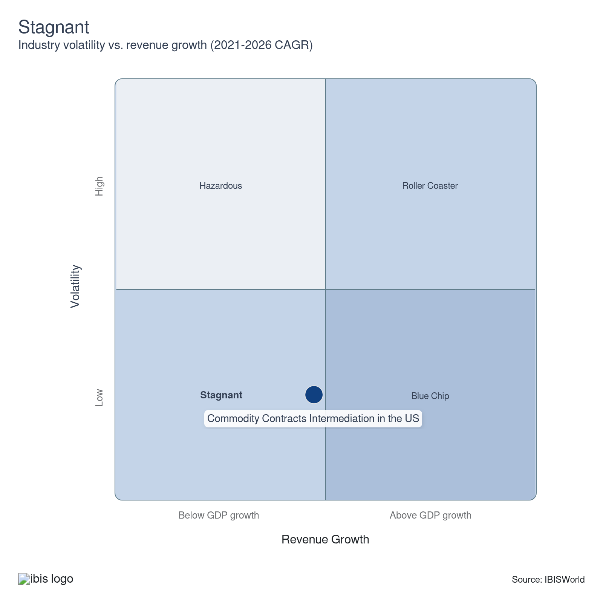

How do successful businesses overcome volatility?
Ability to effectively manage risk
Intermediaries face risks throughout the investment process, from trend confirmation to determining suitable market exposure. Adequate risk management is crucial for balancing potential gains with the inherent uncertainties in any investment strategy.
Leverage economies of scope
By diversifying commodities handled, brokers can reduce dependency on a single market and build up a buffer against individual commodity volatility, providing more stable overall financial performance and simultaneously broadening their client base.
Outlook | ↑ 2026-31 Revenue CAGR +0.4%

What's driving the industry outlook?

Anticipated rate cuts and supply chain volatiltiy will affect demand for commodity contracts
- As inflation continues to stabilize and market confidence remains elevated, the industry will likely encounter demand in commodity trading markets. In addition, the anticipation of interest rate cuts at the onset of the outlook period will support commodity trading, particularly within bullish and long-term commodity contracts.
- Also, the persistence of geopolitical conflicts will affect various commodities during the outlook period, including oil and agricultural prices. Commodity market analysts and trading strategists will continue to monitor geopolitical risks, sanctions, conflicts and trade wars. Sudden disruptions to supply chains and uncertainty regarding geopolitical tensions can cause contract values to fluctuate.
- While positive trends in capital markets and a more dovish Fed will provide a critical domestic investment boost, the anticipated decline in the US dollar and anticipated declines in global oil and agricultural products will add to long-term uncertainty and may push investors toward short-term contracts to mitigate potential long-term risks and price swings in a changing market environment.

Growing emphasis on sustainable products will provide niche commodity opportunities
- A wide range of industries across a variety of sectors are committed to a greener and more sustainable economy, which requires greater input of core metals and minerals. Mineral commodities like copper and lithium are essential for products like electric vehicles (EVs), solar electrical technology and digital technology products like smartphones, with higher demand among consumers traditionally correlating with strong global GDP.
- This global transition toward sustainable goods will enhance commodity prices within the metals and mining space, as greater consumer demand will facilitate the need to construct higher quantities of these products. With the growing price of nonferrous metals expected over the next five years, this will push commodity prices higher for these sustainable metals and the demand for commodity contracts on these products.
- In addition, commodity exchanges and intermediaries will increasingly offer new contracts tied to carbon credits, renewables and emissions. The green derivatives and environmental swaps will increasingly attract a broader base of investors and companies that seek to hedge sustainability risks. Demand for ESG expertise will increasingly jump as operators will need to track and audit environmental attributes.

Adoption of smart contracts will enhance digitization of client records
- As more brokers look to digitize client records and adopt the latest technological innovation across their internal workflows, the adoption of smart contracts will accelerate these trends. Smart contracts enable self-execution of agreements between two parties, with the contracts being stored on a decentralized blockchain ledger.
- According to S&P Global, the increasing adoption of artificial intelligence (AI) will be an important accelerant toward blockchain adoption, with AI enabling easier data processing and using real-time financial data to verify transactions. Companies will increasingly expect greater transparency and risk controls, positioning blockchain as a vital technology during the outlook period.
- Larger and more established commodity contracts intermediaries will continuously adjust their business models to retain market share against smaller new entrants. Strategic merger and acquisition activity will enable larger industry companies to capture and retain a larger retail flow of commodity contracts. However, new entrants are expected to enter the industry and drive up industry establishments and increase fragmentation in the industry.

The growing use of AI and technological tools will continue reshaping the industry
- Commodity trading firms, fintech startups and established intermediaries are investing in AI tools, big data analytics and automation. These technologies streamline operational processes, limiting expenses while enhancing predictive analytics and optimizing contract execution for commodities. Industry firms will increasingly leverage AI to better compete with intensifying competition in the industry.
- Risk management professionals have increasingly used machine learning to forecast extreme price swings and demand surges during the current period and this trend is anticipated to continue into the outlook period. AI-driven scenarios and models are integrated with market news and satellite imagery, giving early warning of supply shocks and the potential for price swings in commodity prices. Faster and better-informed decisions cut response times but depend on data quality and model validations.
- Commodity brokers and exchanges are anticipated to execute an increasing numbers of trades via automated platforms using mobile and online platforms. Algorithmic trading reduces latency and operational errors, while increasing contract turnover. Compliance departments will increasingly invest in trade surveillance and system monitoring to reduce operational and reputational risks.

Volatility in crude oil prices stemming from the conflict with Iran will shake up the industry
- Volatile crude oil prices and the possibility of persisting conflict between the United States and Iran will structurally elevate hedging and trading demand in crude and refined products, impacting commodity contracts intermediaries. A sustained geopolitical risk premium around the Strait of Hormuz and oil supply shocks will actively affect crude oil prices and liquidity risk.
- More erratic oil prices tighten funding constraints and increase margin, collateral and capital intensity for commodity dealers. Spikes in implied and realized volatility will drive procyclical initial and variation margins. Industry operators will likely increasingly upgrade liquidity management, diversify funding sources and optimize clearing strategies to avoid forced deleveraging in periods of significant stress.
- Geopolitical risk around a potential prolonged conflict with Iran will create outsized tail risks for the industry. Oil supply disruption in the Middle East could potentially push crude oil prices higher during the outlook period. As a result, commodity intermediaries will embed stress-testing for chokepoint closures and use contracts for downside protection.
Life Cycle | Mature

Why is the industry mature?

Contribution to GDP
Commodity contracts intermediation services have grown at a faster pace compared to the U.S. GDP growth. Strong market acceptance and an enhanced regulatory structure generates strong contributions to the U.S. economy. Also, volatile markets such as the oil market and oil market has garnered greater demand for commodity contracts during the period.

Market Saturation
There is considerable market saturation due to a diversified service stream, enabling new entrants to enter the industry. Higher competition within popular services forces commodity contracts intermediators to lower fees to remain competitive. Due to the growing demand of industry services there has been an influx of new entrants, boosting the number of industry establishments.

Innovation
Technological advancements and the embrace of automation has driven innovation across brokers’ workflow. The use of Web 3.0 and new technologies such as blockchain ensure brokers remain relevant in the digital age.

Consolidation
Investors prefer brokerages that have strong capital structure and a strong reputation. This preference has led to increased consolidation in areas with robust financial markets. In addition, larger and more reputable firms consolidate to improve operations, reduce operating costs and improve profit margins.

Technology and Systems
To tackle growing regulatory demands, commodity contract intermediators turn to cost-efficient technologies and incorporate new systems, such as AI. These systems are crucial for analyzing data, assessing risks and executing trades effectively.

4. Products and Markets
https://my.ibisworld.com/us/en/industry/52316/products-and-markets
Largest Market  $5.5bn  Trading derivatives on own account | Product Innovation  Moderate

Key Takeaways
- The growing popularity of commodities across major brokerages enhances market diversification. Futures contracts are traded on a futures exchange, although some major brokerages incorporate commodity trades into their service offering.
- Commodity contracts effectively hedge against price fluctuations. These financial tools mitigate investment risks, safeguarding both against potential losses and preserving profits in volatile market conditions.

Products and Services
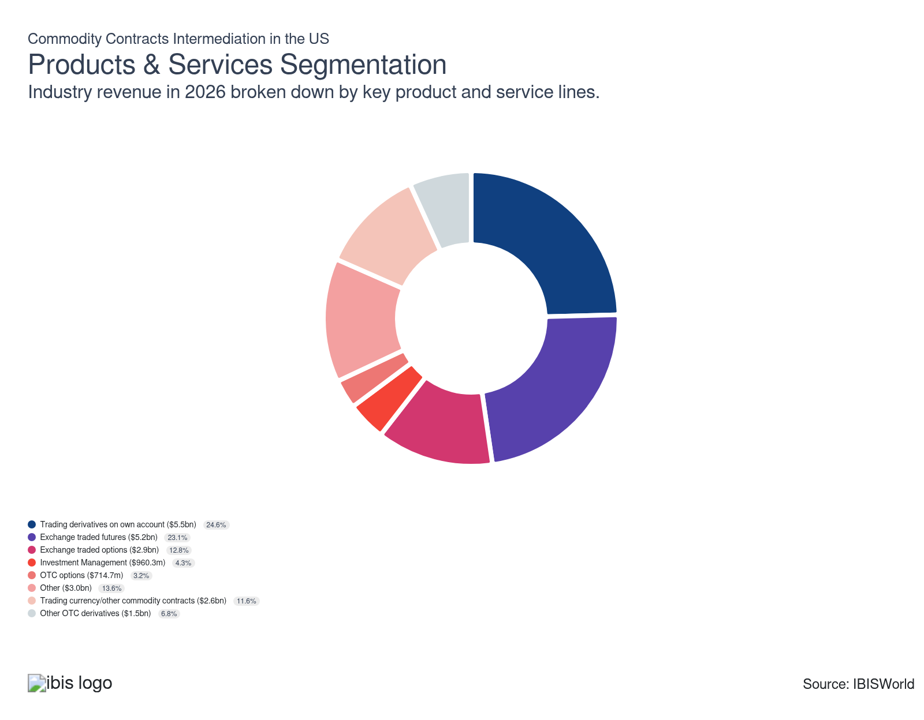

How are the industry’s products and services performing?

Derivatives continue to be affected by geopolitical tensions
- Commodity derivatives are financial securities that offer returns based on the value of an underlying commodity, such as agricultural products, energy resources and foreign currency. Derivatives involve two separate parties within any transaction: dealers and brokers. Dealers, also known as principals, buy and sell derivatives for their own account, generally on a spread basis.
- Brokers, also known as agents, buy or sell derivatives on behalf of clients on a commission or transaction fee basis. The continued tensions in the Middle East and the Ukraine-Russia war has exacerbated price volatility for derivatives, particularly in energy commodities and agriculture.

Future contracts are closely tied to the real economy
- Futures contracts, which are traded on centralized exchanges, represent a commitment to buy or sell a commodity at a specified date and price in the future. Future contracts are primarily used by farmers and businesses to control possible price and supply fluctuations, with oil futures an example of a lucrative future contract that can be prone to wild price swings.
- External factors, such as higher oil production or limited supply of a particular food item due to a viral outbreak, drastically impact future contract prices. Rapid market shifts require the industry to adapt swiftly in pricing and risk management, underscoring the industry's focus on global events and supply chain fluctuations.

Economic instability enhances options contracts volatility
- Options provide the right, but not the obligation, to buy or sell a commodity at a specified price and within a certain period. Option contracts, originally arising as another means to control price and supply fluctuations, are more often used to take on larger risk positions in financial markets for the potential of bigger gains.
- Recent spikes in inflationary pressures have caused considerable price swings in options contracts across a variety of commodities, such as oil and agricultural products. Rapid cost increases and supply shifts have triggered wide price swings, forcing traders and intermediaries in the commodity markets to continually adjust strategies and manage heightened risks.

Proprietary trading is higher risk with potentials of higher rewards
- Trading on a firm's own account, commonly referred to as proprietary trading, involves a firm trading to take on their own risk, rather than trading for a client.
- This type of trading involves more risk as it creates direct exposure to the value of the commodities; this could result in strong losses or gains for the firm. Firms use these financial instruments to accelerate potential gains but do so by taking on increased investment risk.

Continued economic stabilization creates niche demand for OTC options
- OTC trading is the buying and selling of commodities and contracts that are not listed on a centralized exchange, but rather through a broker between two independent parties. Forwards are like futures, except they are nonstandardized OTC derivatives. Depending on where derivatives trade, they are classified as either OTC or listed.
- Listed derivates trade on exchanges and are more structured and standardized, whereas OTC securities are private transactions completed without the use of an intermediary.

What are innovations in industry products and services?

Data analytics and artificial intelligence (AI)
- Companies are increasingly investing in digital tools to make account management more convenient and accessible for users. This investment includes the deployment of mobile platforms and user-friendly interfaces, allowing clients to execute trades and manage contracts from virtually anywhere.
- Advancements in data analytics and artificial intelligence (AI) enhance operational efficiency by providing predictive insights and automated trend analysis, which optimizes trading strategies and improve customer service.

Blockchain technology is changing the dynamics of commodity trading
- Smart contracts, developed through blockchain technology, automate and streamline commodity trading processes by eliminating intermediaries and reducing transaction costs.
- Blockchain provides a transparent and immutable ledger, allowing participants to track and verify the origin and movement of goods. This transparency increases trust and reduces the risk of fraud, enhancing the reliability and security of commodity trading services.

What products or services do successful businesses offer?
Comply with required product standards
Brokers that meet the latest regulatory standards enhance trust and credibility with clients and stakeholders. Adherence to the latest regulations is critical, as it ensures smooth transactions and minimizes legal and operational risks, enhancing service quality and reliability.
Manage exchange rates for product sales
Effective management of exchange rates is crucial because it impacts profitability when dealing with international transactions. By minimizing currency fluctuations, brokers can optimize returns and ensure competitive pricing in global transactions.

Major Markets
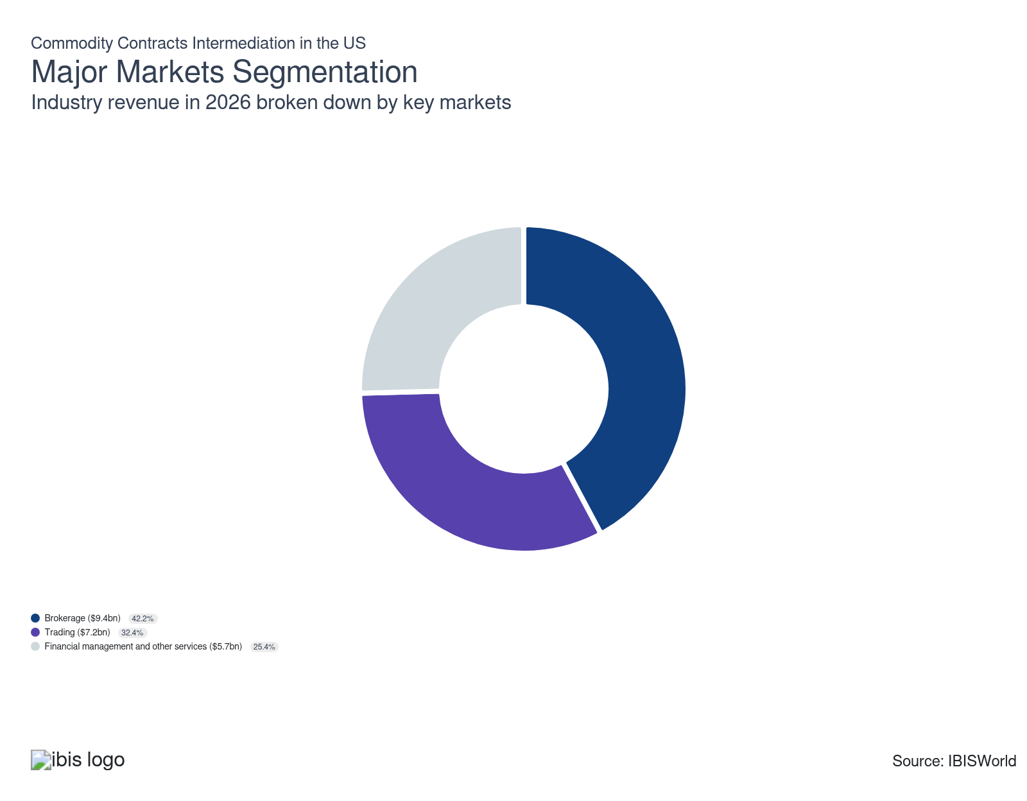

What’s influencing demand from the industry’s markets?

Efficient risk management associated with commodities boosts brokerage market demand
- Brokerage markets continue to generate the largest revenue stream, as greater digitization of futures trading and higher commodity volatility has enhanced traders’ appetite for commodity trades. Buying and selling commodities is a risk management strategy to protect the investment against losses and shielding profit.
- For example, farmers who want to secure the future price of their crop as well as companies that need to buy a commodity, such as steel or aluminum, in the future and want to lock in its price generally turn to commodity contracts to secure a price, especially when purchasing in significant quantities or when market prices are volatile.
- Figures of the relative size of each type of downstream market are not well-documented. However, the division between brokering on behalf of clients, trading on a firm's own account, and the management of financial market clearing products on behalf of clients is readily available from the United States Census.

Nonmember firms (pensions, mutual funds, ETFs, insurance companies) are increasing in size
- Commodities are now seen as a distinct asset class that is a crucial part of portfolio diversification and returns, generating greater interest among financial management and other market services. Individuals speculate on commodity prices and use them as an integral diversification tool in their portfolio. Most of these speculators gain exposure to commodities through exchange-traded funds (ETFs), an investment vehicle that is traded on an exchange much like a stock.
- Institutional traders (insurance companies and pension funds) also use investment vehicles such as mutual funds and ETFs to speculate on commodities to take advantage of rising commodity prices and hedge against future inflation or against volatile price movements.

International Trade

Some industries don't directly import or export goods. See reports at the manufacturing level for international trade data on relevant products.

5. Geographic Breakdown
https://my.ibisworld.com/us/en/industry/52316/geographic-breakdown

Key Takeaways
- The Great Lakes region hosts the largest number of establishments. Major cities such as Chicago act as a key hub for major commodity exchanges in the area, with the region also hosting considerable commodity producers.
- The Plains is the second-largest broker region due to high saturation of agricultural producers. Farmers there rely on brokers’ services to shield against unpredictable price and supply shifts.

Business Locations
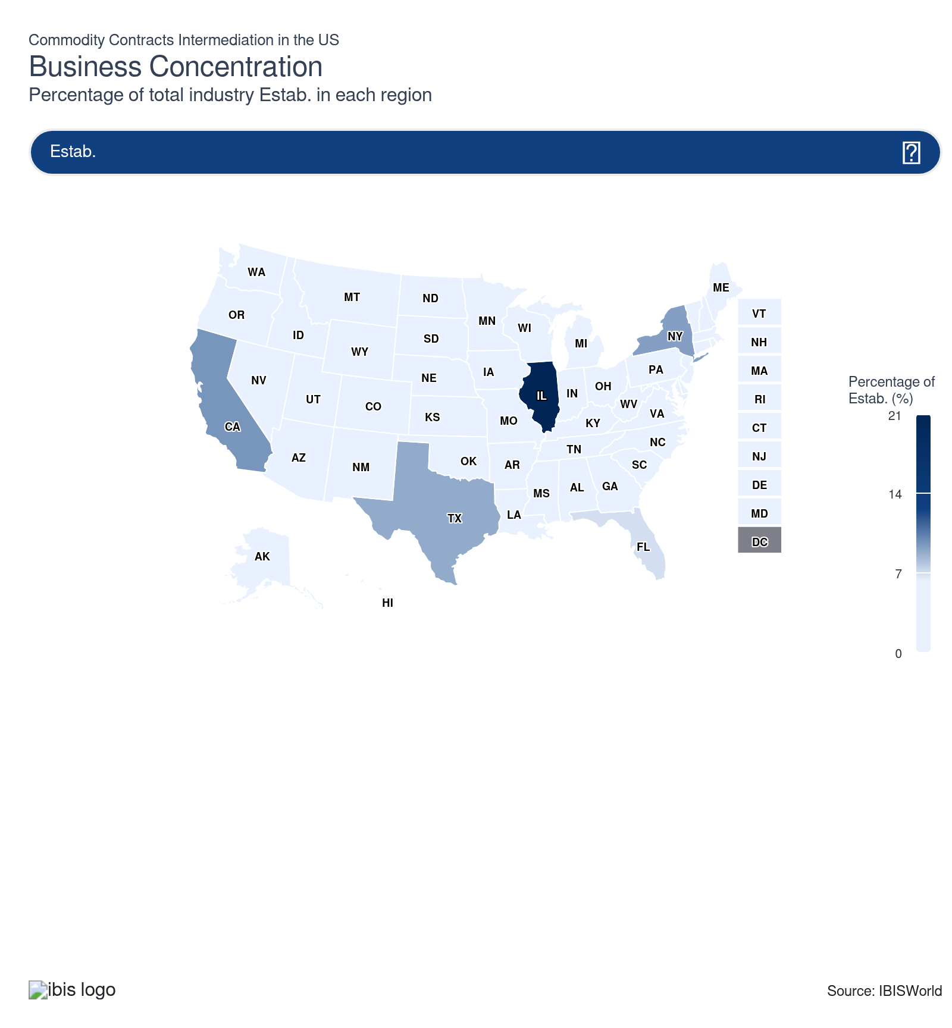
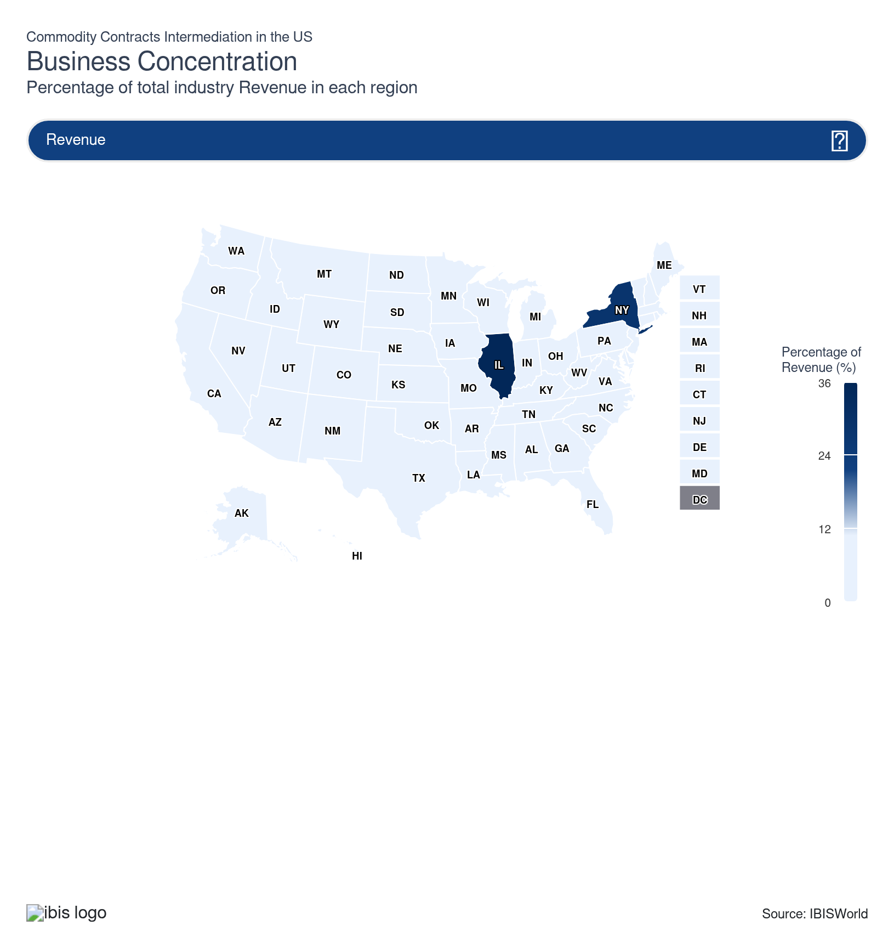
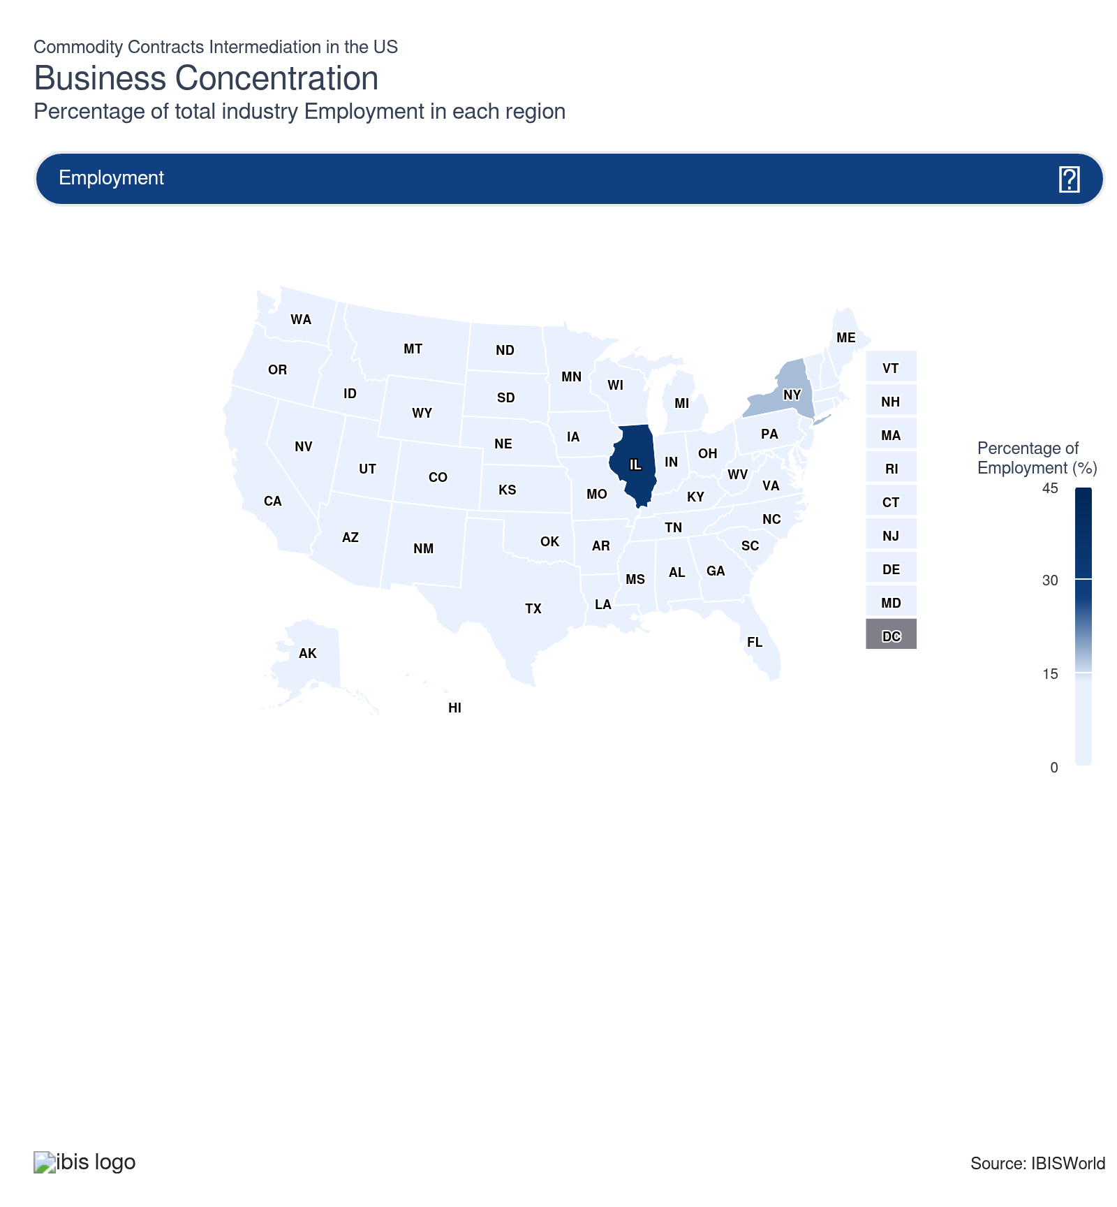
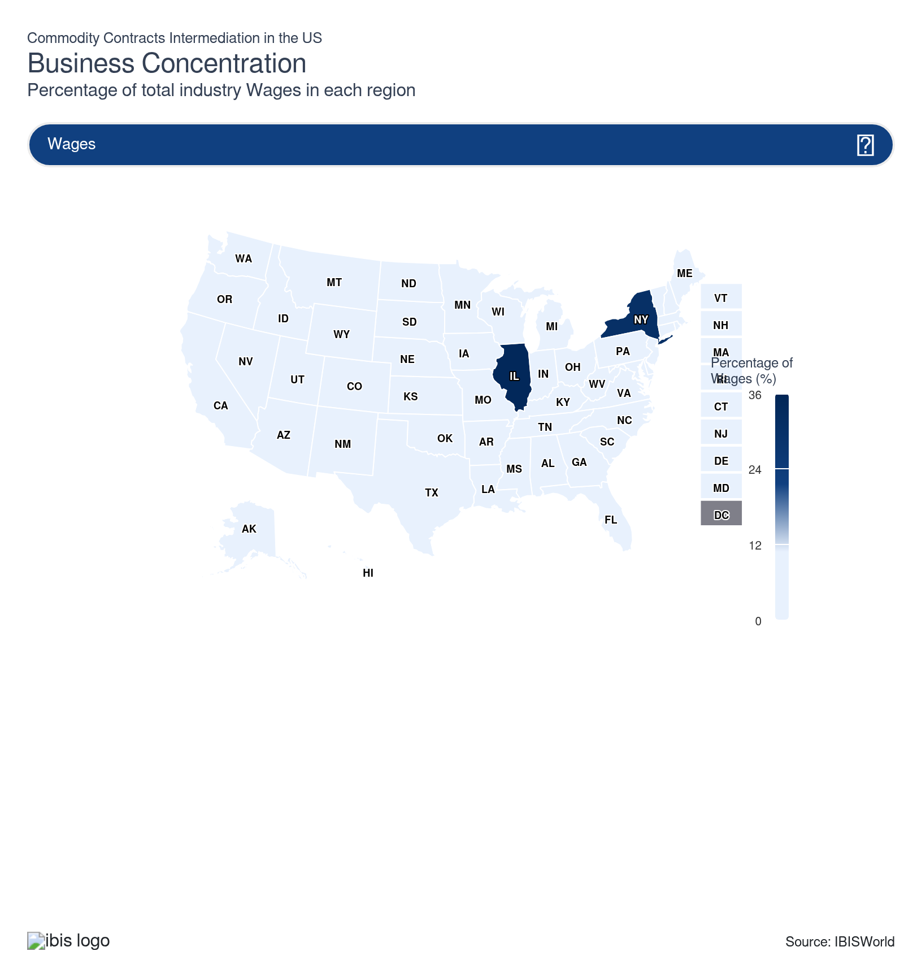
State | Estab.  Units | Estab.  % | Revenue  $m | Revenue  % | Wages  $m | Wages  % | Employment  Units | Employment  % | Population  %
Illinois | 1,402 | 21.4 | 7,868.0 | 35.2 | 2,927.0 | 34.7 | 9,735 | 34.2 | 3.7
New York | 603 | 9.2 | 6,254.3 | 28.0 | 2,566.9 | 30.4 | 4,993 | 17.6 | 5.8
California | 626 | 9.6 | 1,050.3 | 4.7 | 333.0 | 3.9 | 2,169 | 7.6 | 11.5
Connecticut | 108 | 1.7 | 1,405.7 | 6.3 | 580.1 | 6.9 | 900 | 3.2 | 1.1
Texas | 576 | 8.8 | 1,208.0 | 5.4 | 699.7 | 8.3 | 2,223 | 7.8 | 9.4
Florida | 453 | 6.9 | 547.9 | 2.5 | 186.4 | 2.2 | 1,127 | 4.0 | 7.0
Iowa | 182 | 2.8 | 255.4 | 1.1 | 115.5 | 1.4 | 1,631 | 5.7 | 0.9
New Jersey | 190 | 2.9 | 634.2 | 2.8 | 223.5 | 2.6 | 971 | 3.4 | 2.8
Minnesota | 165 | 2.5 | 332.7 | 1.5 | 98.5 | 1.2 | 405 | 1.4 | 1.7
Nebraska | 178 | 2.7 | 51.1 | 0.2 | 14.2 | 0.2 | 178 | 0.6 | 0.6
Alabama | 30 | 0.5 | 218.6 | 1.0 | 12.0 | 0.1 | 120 | 0.4 | 1.5
Colorado | 135 | 2.1 | 49.3 | 0.2 | 19.8 | 0.2 | 135 | 0.5 | 1.8
Missouri | 68 | 1.0 | 66.7 | 0.3 | 25.4 | 0.3 | 392 | 1.4 | 1.8
Kansas | 128 | 2.0 | 151.9 | 0.7 | 29.3 | 0.3 | 225 | 0.8 | 0.9
Wyoming | 38 | 0.6 | 64.8 | 0.3 | 7.6 | 0.1 | 283 | 1.0 | 0.2
Pennsylvania | 67 | 1.0 | 147.3 | 0.7 | 18.7 | 0.2 | 119 | 0.4 | 3.8
Massachusetts | 94 | 1.4 | 42.4 | 0.2 | 22.3 | 0.3 | 94 | 0.3 | 2.1
Maryland | 56 | 0.9 | 134.6 | 0.6 | 14.2 | 0.2 | 79 | 0.3 | 1.8
Virginia | 44 | 0.7 | 72.8 | 0.3 | 20.6 | 0.2 | 84 | 0.3 | 2.6
Kentucky | 38 | 0.6 | 133.6 | 0.6 | 6.6 | 0.1 | 48 | 0.2 | 1.3
Tennessee | 83 | 1.3 | 46.4 | 0.2 | 14.8 | 0.2 | 97 | 0.3 | 2.1
Michigan | 69 | 1.1 | 127.0 | 0.6 | 14.0 | 0.2 | 151 | 0.5 | 3.0
New Hampshire | 30 | 0.5 | 131.4 | 0.6 | 15.8 | 0.2 | 106 | 0.4 | 0.4
Georgia | 82 | 1.3 | 31.2 | 0.1 | 17.8 | 0.2 | 127 | 0.4 | 3.3
Rhode Island | 12 | 0.2 | 19.1 | 0.1 | 11.9 | 0.1 | 139 | 0.5 | 0.3
Indiana | 80 | 1.2 | 19.2 | 0.1 | 5.2 | 0.1 | 80 | 0.3 | 2.0
Utah | 57 | 0.9 | 89.1 | 0.4 | 17.2 | 0.2 | 117 | 0.4 | 1.0
South Dakota | 73 | 1.1 | 29.2 | 0.1 | 7.1 | 0.1 | 84 | 0.3 | 0.3
Oregon | 43 | 0.7 | 75.7 | 0.3 | 4.3 | 0.1 | 50 | 0.2 | 1.2
Ohio | 57 | 0.9 | 16.2 | 0.1 | 12.9 | 0.2 | 125 | 0.4 | 3.5
Wisconsin | 64 | 1.0 | 19.4 | 0.1 | 7.4 | 0.1 | 116 | 0.4 | 1.7
North Carolina | 52 | 0.8 | 63.8 | 0.3 | 12.1 | 0.1 | 79 | 0.3 | 3.3
Washington | 53 | 0.8 | 15.5 | 0.1 | 4.4 | 0.1 | 53 | 0.2 | 2.3
Arizona | 45 | 0.7 | 37.8 | 0.2 | 4.3 | 0.1 | 46 | 0.2 | 2.2
Oklahoma | 49 | 0.7 | 3.8 | 0.0 | 1.4 | 0.0 | 49 | 0.2 | 1.2
Nevada | 49 | 0.7 | 5.4 | 0.0 | 3.3 | 0.0 | 49 | 0.2 | 1.0
Idaho | 45 | 0.7 | 11.5 | 0.1 | 3.9 | 0.0 | 51 | 0.2 | 0.6
South Carolina | 45 | 0.7 | 6.8 | 0.0 | 3.8 | 0.0 | 49 | 0.2 | 1.6
Arkansas | 33 | 0.5 | 10.7 | 0.0 | 5.4 | 0.1 | 40 | 0.1 | 0.9
Delaware | 29 | 0.4 | 6.0 | 0.0 | 4.8 | 0.1 | 42 | 0.1 | 0.3
Montana | 37 | 0.6 | 11.4 | 0.1 | 1.8 | 0.0 | 37 | 0.1 | 0.3
North Dakota | 34 | 0.5 | 6.6 | 0.0 | 3.2 | 0.0 | 45 | 0.2 | 0.2
Hawaii | 34 | 0.5 | 2.3 | 0.0 | 0.7 | 0.0 | 34 | 0.1 | 0.4
Mississippi | 23 | 0.4 | 6.2 | 0.0 | 0.5 | 0.0 | 23 | 0.1 | 0.9
Louisiana | 23 | 0.4 | 0.7 | 0.0 | 0.5 | 0.0 | 23 | 0.1 | 1.3
New Mexico | 23 | 0.4 | 2.2 | 0.0 | 0.9 | 0.0 | 23 | 0.1 | 0.6
West Virginia | 8 | 0.1 | 2.4 | 0.0 | 0.5 | 0.0 | 8 | 0.0 | 0.5
Maine | 8 | 0.1 | 2.1 | 0.0 | 0.5 | 0.0 | 8 | 0.0 | 0.4
Vermont | 8 | 0.1 | 1.9 | 0.0 | 0.1 | 0.0 | 8 | 0.0 | 0.2
Alaska | 8 | 0.1 | 2.0 | 0.0 | 0.5 | 0.0 | 8 | 0.0 | 0.2

Where are industry businesses located?

A high saturation of prominent commodity exchanges boosts Great Lakes popularity
- A significant chunk of commodity trade occurs within the Great Lakes region due to high presence of core trading groups and a robust commodity landscape. Also, the Great Lakes region is renowned for its manufacturing and industrial production, providing a supportive backdrop for the financial trading industry, including commodities and contracts intermediation.
- In states like Illinois, prominent commodity groups such as the Chicago Mercantile Exchange (CME) and Chicago Board of Trade (CBOT) are headquartered in Chicago, further boosting intermediators’ presence. The legacy of established financial hubs allows easier access to experienced staff, proven business services and established trust networks essential for commodity contracts trading.
- Operators must navigate a competitive market landscape with both regional and global firms vying for major exchange deals, requiring sophisticated trading technology. Regulatory complexity is high due to state, federal and international trading relationships, leading to elevated compliance costs and regular audits.

A robust commodity presence bolsters trading opportunities in the Plains
- Commodity contract intermediaries are relatively popular in the Plains primarily because of the extensive presence of farmers. The agricultural focus of the region creates a significant demand for these services as they offer a means to hedge against market volatility. Agricultural prices have experienced volatility throughout the current period.
- Farmers are the primary market for future contracts in the region, with these financial instruments offering a valuable tool in market stability and planning, mitigating the risks associated with unpredictable agricultural markets. Regional infrastructure supports large-scale storage and transportation, helping firms manage agriculture inventory risk and season supply variations.
- Harsh climate and weather extremes mean operators must develop robust contingency plans and flexible contract terms to protect against crop and supply failures. Transportation costs and logistical challenges are higher due to the distance from major consumption hubs, requiring strategic planning and advanced risk management, therefore commodity contracts are increasingly used to mitigate risks.

A diverse client presence enhances intermediary popularity in the West
- California has the highest number of brokers in the Western region. This is attributed to the state's diverse economic landscape, which supports various broker needs ranging from agricultural to energy commodities. Farmers in California also heavily engage in commodity contracts to hedge against market volatility, given the state's expansive agricultural industry.
- The region’s diverse resource base includes agricultural, energy and technology commodities, providing unique contract opportunities across multiple sectors. The presence of significant investment capital and venture support enables rapid scaling, derivatives innovation and technology adoption for trading platforms such as those in the commodity contracts intermediation industry.
- Industry operators in urban hubs encounter higher business costs from rents to industry wages, making cost controls and technological innovation essential for growth in the industry. The industry is also home to a diverse client presence enhancing various commodity contracts from operators, supporting industry demand.
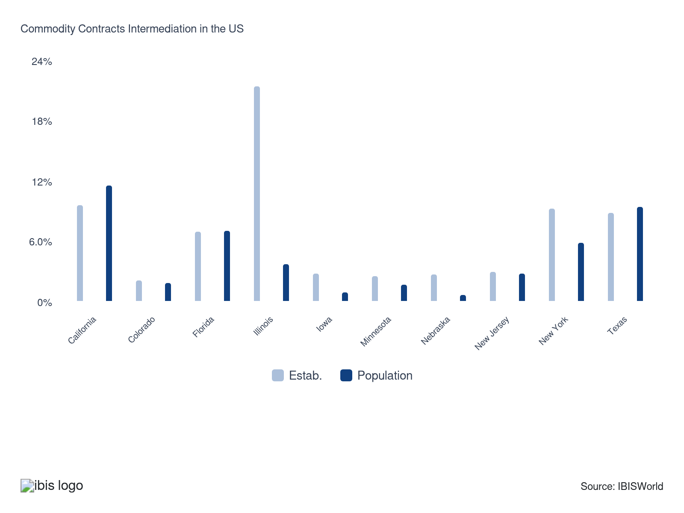

How do businesses use location to their advantage?
Operate in a location that is close to key markets
Brokers setting up their operations near core markets ensures quick responses to market demands and fluctuations, facilitating better client relationships and increasing the chance of securing timely, lucrative deals with a diverse array of clients.
Ensure resource availability
Access to necessary resources like technology and skilled personnel ensures smooth operations, quick adaptations to market changes and more efficient trading processes. Regions with high saturation of core suppliers enhance commodity intermediaries’ presence.

6. Competitive Forces
https://my.ibisworld.com/us/en/industry/52316/competitive-forces

Key Takeaways
- Market concentration remains low, because large private brokers control much of the market and disclose minimal information on revenue from physical and derivatives trading.
- Considerable market fragmentation stems from many small brokers serving local markets. As big banks downsize or exit, large physical commodity traders are capturing more market share.

Concentration
Low

What impacts the industry’s market share concentration?

Lack of centralized markets and transparency enhances fragmentation
- The true market share concentration among brokers is largely indeterminable due to a lack of transparency. Major companies are private firms that often don't disclose detailed financial information about their trades in physical commodities and derivatives.
- Revenue streams among commodity brokers is highly fragmented, with a significant amount of smaller brokers catering to local markets, making it difficult to aggregate meaningful market share data on a national or global scale.
- As large banks downsize or exit from the industry, physical commodity traders increasingly seize a great portion of market revenue. This shift limits consolidation prospects across the industry, allowing independent trading firms to expand influence and seek opportunities across the broader landscape.

Economic shifts create limited opportunities for consolidation
- Interest rates and economic growth levels directly impact the capital available for investment into commodity contracts. Interest rate fluctuations have a significant impact on revenue as lower interest rates can spur investment, while higher rates may limit investment.
- During economic booms, brokers often endure increased market share fragmentation as new entrants and smaller firms enter the market. The increased competition makes it more difficult for larger companies to capture a larger portion of market share in volatile commodity niches.

How do successful businesses handle concentration?
Leverage the company's financial position
In a competitive market, strong financial standing is crucial for brokers to negotiate better deals, withstand market volatility and strengthen long-term client relationships, ensuring long-term stability and competitive advantage.
Leverage business expertise
Brokers with strong market expertise can use it to strengthen their market research and provide excellent investment opportunities for clients. Business expertise helps in navigating complex market conditions and enhances a competitive edge in saturated markets.

Barriers to Entry
Moderate | Steady

What challenges do potential industry entrants face?

Legal
- Commodity contracts intermediaries face an array of regulations and strict compliance requirements. Prospective entrants must pass the National Association of Securities Dealers Series 3 exam, ensuring certification and adherence to the latest intermediation standards. Compliance with standards are designed to ensure transparency and integrity within the industry.

Start-Up Costs
- Brokers face substantial start-up costs due to the high costs of investment in technology, capital and licensing. Having advanced computers are crucial to daily operations. This financial burden poses a challenge for newcomers, especially when competing with established firms boasting economies of scale.

Differentiation
- There is some differentiation due to a wide array of services offered by brokers. New entrants face the challenge of distinguishing themselves from established competitors. Building a unique market position and attracting customers is more difficult in saturated markets.

Labor Expenses
- Commodity contracts intermediation requires considerable input from manual labor and skilled professionals, enhancing overall labor intensity. Hiring experienced investment professionals can be a barrier for new companies attempting to enter the market due to high costs of skilled human capital.

How can potential entrants overcome barriers to entry?
Comply with government regulations
In addition to obtaining a license, intermediators are subject to the supervision of the Securities and Exchange Commission, the Commodity Futures Trading Commission, the National Futures Association and other self-regulating bodies (mainly exchanges).
Develop contacts within key markets
Building solid connections with producers, buyers and financial institutions is crucial for intermediaries to access critical information, market opportunities and secure profitable contracts more effectively.

Substitutes
Low | Steady

What are substitutes for industry services?

Do-it-yourself
- Commodity futures and option contracts serve as viable tools for investors looking to hedge against financial losses by providing a shield against market volatility and locking in prices for future transactions.
- While direct alternatives to commodity intermediation services are limited, consumers interested in trading commodities may opt for a do-it-yourself approach through traditional brokerages. Trading cryptocurrencies has also emerged as an alternative. Though considerably riskier, it presents opportunities for those interested in market speculation, offering high potential returns along with substantial risks.

How do successful businesses compete with substitutes?
Leverage the company's business expertise
Brokers thrive by using their deep knowledge of commodities to offer specialized services that surpass substitute options. By generating expert analysis within a complex market, brokers can deliver tailored solutions for their clients while strengthening market reputation.
Conduct market research
Brokers that conduct efficient market research can maintain strong understanding of market trends and customer needs. By staying informed, brokers can undermine demand for substitutes via superior information services, which boosts trust with new customers.

Buyer & Supplier Power
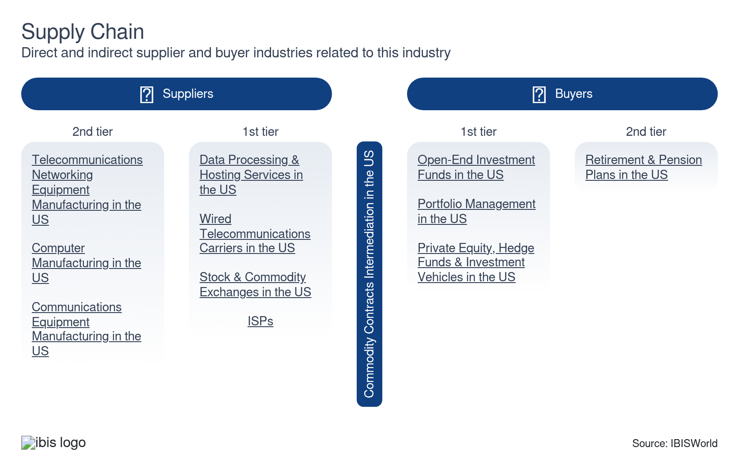

What power do buyers and suppliers have over the industry?

Buyers: knowledge and service expertise
Moderate | Increasing
- Institutional buyers with substantial markets knowledge and expertise exert significant influence over brokers, with buyers’ points of emphasis focusing on quality of service.
- Buyers equipped with access to a wide range of alternative derivative contracts hold more bargaining power, increasing their leverage over incumbent brokers when looking to acquire commodity contracts with lower commission fees.

Suppliers: high switching costs and supply leverage
High | Increasing
- Suppliers are heavily influential due to the high switching costs associated within the hardware and software spaces, particularly as brokers continue to expand digitization efforts.
- Individual sectors, such as farmers and miners, control the quality and supply of commodities, directly impacting the trading of financial derivatives. Suppliers with economies of scale and strong name recognition can set higher market costs for their services, especially among software and hardware providers.

How do successful businesses manage buyer & supplier power?
Leverage economies of scope
By achieving economies of scale, brokers can lower costs and offer competitive pricing, enhancing their bargaining power with both buyers and suppliers.
Possess accurate information
Access to accurate market trends and information empowers intermediation brokers to make informed decisions and negotiate better terms with both buyers and suppliers, enhancing transparency and ensuring transactions reflect true market conditions.

7. Companies
https://my.ibisworld.com/us/en/industry/52316/companies

No single company accounts for more than 5% of total industry market share.

8. External Environment
https://my.ibisworld.com/us/en/industry/52316/external-environment

Key Takeaways
- Commodity contract intermediaries face rigorous and consistent regulation. A slew of regulations focusses on proper licensing and adherence to financial laws, influencing how brokers function within these regulatory frameworks.
- Most assistance is derived from private groups. The largest assistance stream is derived from the Commodity Markets Council, which acts as an advocacy group for commodity markets.

External Drivers

What demographic and macroeconomic factors impact the industry?
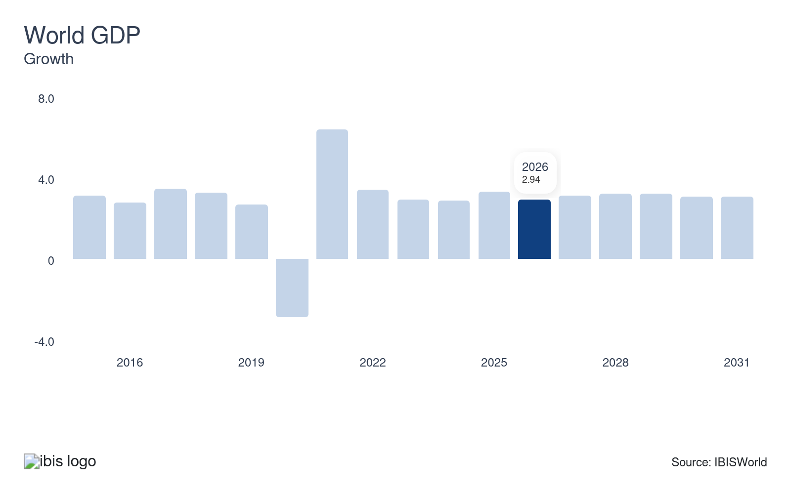
World GDP measures the total value of globally produced goods and services. Growth in global GDP influences global supply and demand for commodities, as the consumption of commodities such as crude oil and agricultural products rises. In particular, concentrated periods of growth in certain geographic markets provides the opportunity for arbitrage opportunities and industry returns, which can be compounded by growing trade volumes.
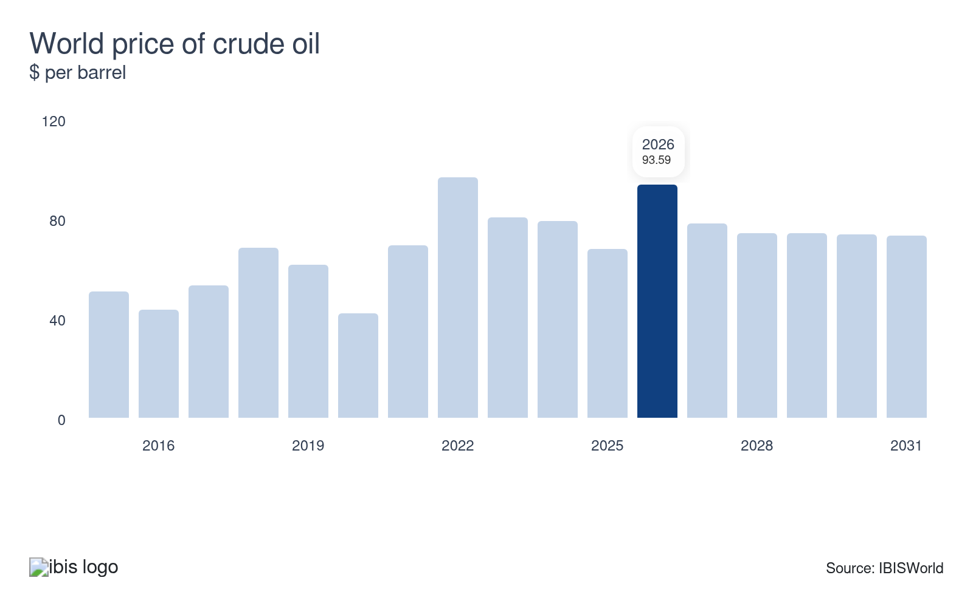
Crude oil is used as a consumer good and as an input for various manufacturing and logistics industries, playing a systemically central role in the economy and is prone to volatility. To protect against changes in oil prices or to capitalize on the volatility, many brokers purchase and sell crude oil derivatives, with sharp declines in the world price of crude oil shrinking derivative ROI and posing a potential threat to brokers.
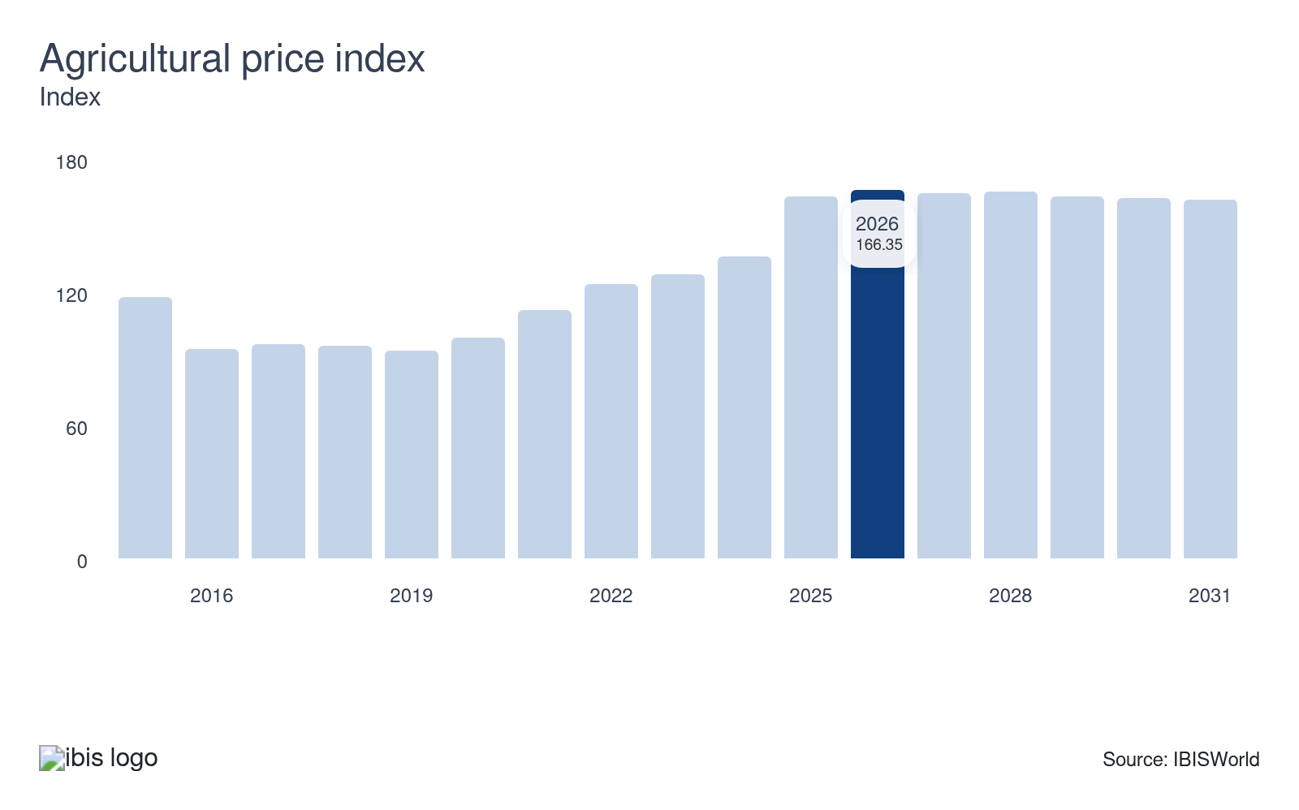
The agricultural price index is a measure of prices received by farmers for livestock and crops, which underpin returns on trading in agricultural commodity contracts. Volatility in agricultural commodity prices creates greater demand for agricultural commodity derivatives. Brokerage fees from agricultural commodity contracts trading on behalf of clients generate a considerable revenue niche, with growth in the index raising the profitability of these contracts and representing a potential opportunity for brokers.
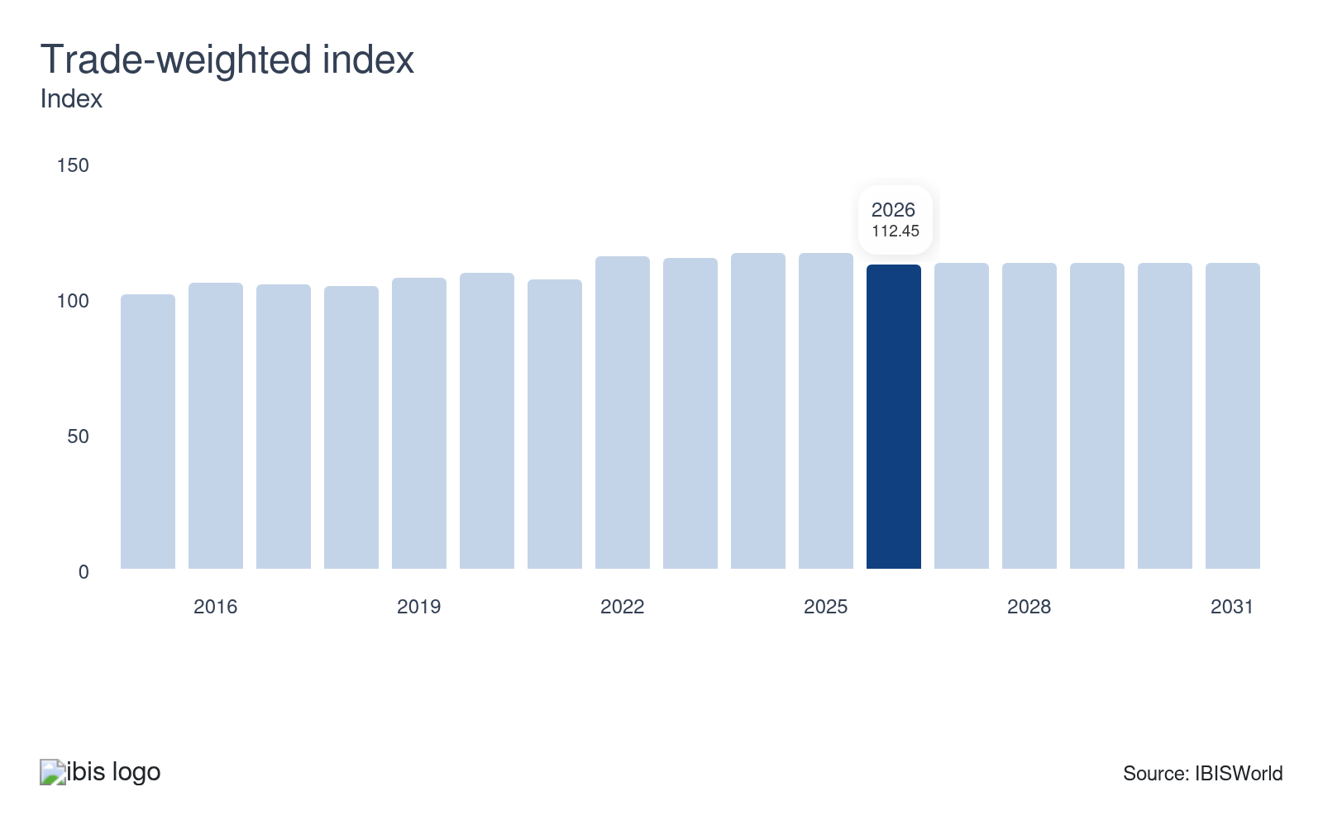
The trade-weighted index (TWI) measures the strength of the US dollar relative to its major trading partners. An increase in the TWI indicates that the US dollar has appreciated relative to its trading partners. Traditionally, an appreciating US dollar results in an ultimate decrease in the price of commodities, which are priced in US dollars.

Regulation & Policy
High | Increasing

What regulations impact the industry?

Commission regulatory structures
The Commodity Futures Trading Commission (CFTC) and the Securities and Exchange Commission (SEC) are vital regulatory bodies for the Commodity Contracts Intermediation services industry. Established in 1974, the CFTC oversees the commodity futures and options markets, ensuring transparency and market integrity. Meanwhile, the SEC regulates securities derivatives. Both agencies work to prevent market manipulation, safeguard investors and maintain fair trading practices that reinforces trust in financial markets.

The Commodity Exchange Act of 1936
The Commodity Exchange Act of 1936 aimed to curb market manipulation in the grain industry, addressing concerns from the late 19th and early 20th centuries. The law sought to reduce speculative practices believed to increase price volatility and harm farmers. During periods of market instability, this regulation worked to protect agricultural producers by implementing stricter controls on futures trading. The 1974 Act maintained these core regulatory objectives.

The National Futures Association (NFA)
The National Futures Association (NFA), under the oversight of the Commodity Futures Trading Commission (CFTC), serves as the primary self-regulatory organization for the US derivatives industry. Established under Section 17 of the Commodity Exchange Act, it enforces strict compliance and ethical standards among entities that handle customer funds or provide trading advice. Brokers and firms engage in futures trading and must register with NFA and CFTC. This regulatory framework promotes fair trading practices, safeguards for investor interests and supports transparency.

The Commodity Futures Modernization Act (CFMA)
The Commodity Futures Modernization Act (CFMA) of 2000 brought significant changes to the Commodity Exchange Act of 1936. It shifted the Commodity Futures Trading Commission (CFTC) from a direct regulator to an oversight role, enabling greater flexibility in futures trading. The CFMA also lifted the ban on single stock futures and clarified the legal framework for over-the-counter derivatives, facilitating market growth and innovation across new products.

Dodd-Frank Wall Street Reform and Consumer Protection Act of 2010
The Dodd-Frank Act's Volcker Rule restricts U.S. banking entities from engaging in proprietary trading or owning hedge and private equity funds. This regulation aims to curb the speculative actions that contributed to past financial crises. Within the commodity contracts space, banks faced reduced trading revenue which prompted some to sell their commodity trading units, reflecting the rule's widespread influence.

Assistance
None | Steady

What assistance is available to this industry?

Public support doesn't apply to the industry
The Commodity Contracts Intermediation industry doesn't receive any public sector support.

The Commodity Markets Council (CMC)
The Commodity Markets Council (CMC) offers advocacy support to brokers across the United States. CMC works on ensuring safe and competitive commodity markets by focusing on Dodd-Frank regulations and reducing regulatory burdens on commodity end-users. This assistance aims to streamline trading processes and lower costs, fostering a more efficient market environment for brokers.

9. Financial Benchmarks
https://my.ibisworld.com/us/en/industry/52316/financial-benchmarks
Profit Margin  6.9 %  ↓ Lower than sector | Average Wage  $297k  ↑ Higher than sector | Largest Cost  Wages  37.8% of Revenue

Key Takeaways
- High commodity price swings cut into profitability. Greater fluctuations in prices of core commodities, such as oil and agricultural products, limited interest from traders avoiding volatility.
- Consistent need for qualified labor bolsters wage expenses. Skilled financial professionals with greater technical knowhow have accelerated wage costs for brokers.

Cost Structure
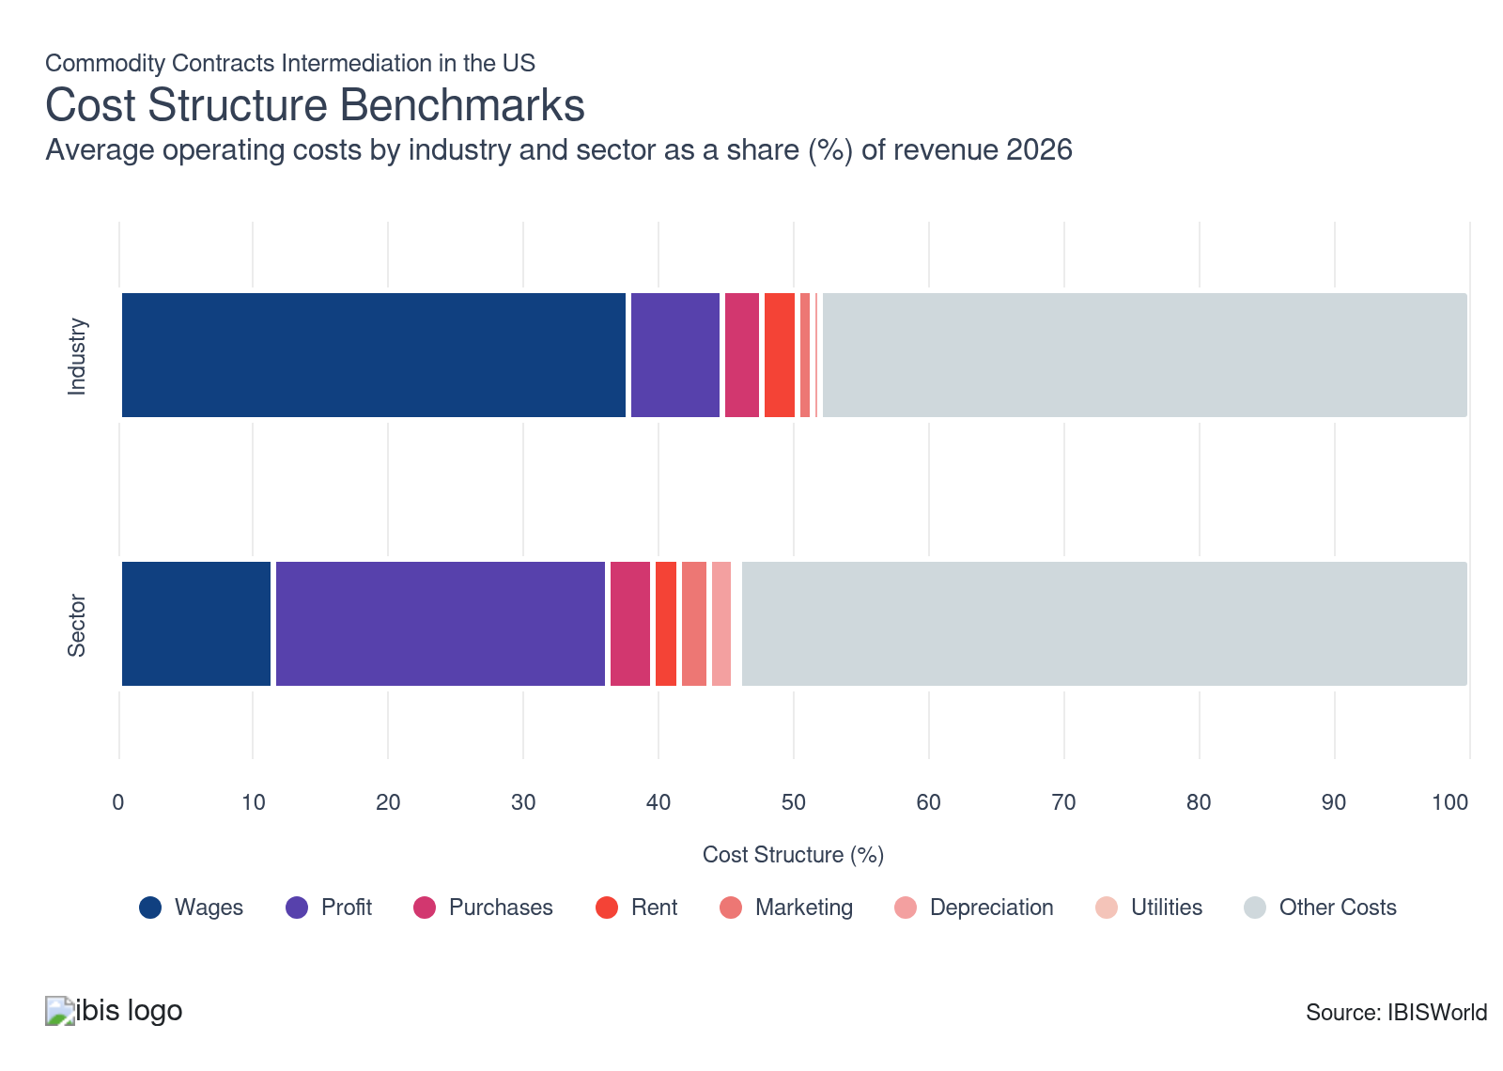
Chart displays current year only in the PDF version of this report. You can view and download chart for all other years associated with this industry on my.ibisworld.com.

What trends impact industry costs?

A high emphasis on quality client service enhances wage costs
- Wages continue to make up the largest expenditure for commodity contract intermediaries, as the industry remains heavily dependent on skilled workers. Industry wages as a share of revenue climbed during the period and account for over one-third of revenue in the current year.
- Brokers rely heavily on analysts, fund administrators and administration staff for each of their product offerings, with these positions having high educational barriers and requiring different financial licenses. Investment in new technologies and systems have stabilized labor costs in recent years, although the overall trade process and market research continues to depend on manual labor.

Profit lages depsite significant growth and volatility in commodity prices
- Profit, measured as earnings before interest and taxes, declined during the period. Despite the increases in the commodity prices of oil and agriculture during the period, industry profit slumped. Volatile oil prices and sharp rises stemming from the conflict with Iran has caused the world price of crude oil to soar in the current year.
- Commodity brokers' average commissions and transaction fees declined and their profit margins were pressured by intensifying competition and new trading technologies. Brokers typically earn less profit than commodity dealers because they earn revenue from commission and transaction fees on variable client trade volumes instead of from trading gains.
- The escalating conflict with Iran and disruptions around the Strait of Hormuz are raising geopolitical risks and driving significant increases in the world price of crude oil, amplifying the volatility of prices that commodity contract intermediaries must warehouse. Commodity intermediaries will encounter elevated operational, insurance risks on cargoes and systemic exposures, affecting industry profit.

Limited reliance on physical goods dampens purchase costs
- Purchase costs remain a niche expenditure for brokers, with most costs including administrative and clerical materials to provide relevant brokerage services to clients. Purchase costs are necessary for industry operations as purchases include computers and other office equipment.
- Heightened inflationary pressures temporarily pushed up many core purchase costs, although brokers’ increasing reliance on automation and artificial intelligence (AI) continues to maintain purchase levels. Overall, purchase costs have lagged slightly during the period.

Rent expenses have lagged during the period
- Rent expenses comprise a small share of revenue and have declined over the past five years. Rent expenses can vary as office spaces that are larger and located in areas with significant traffic, such as urban metros, generally experience increased rent costs.
- Fluctuating real estate markets and the location of leased offices significantly influence the average rent costs for industry companies. In addition to office spaces, rent expenses include trading floors and other work environments necessary for market activity.

Marketing costs have been steady
- Marketing costs have been steady during the period. Operators have advertised through traditional channels and digital channels, including financial media and trade publications. Industry operators invest in advertising campaigns to increase visibility in the market.
- Maintaining an engaging digital presence such as websites, social media and online content, generates ongoing costs for operators hiring designers, content creators and technical staff to support brand awareness and lead generation in a competitive marketplace.

Depreciation costs lag and are minimal
- Depreciation expenses have lagged during the period and are minimal. Depreciation is used to depreciate an asset costs over its estimated useful life. Depreciation costs include physical assets such as computers, printers and other office equipment used for operations.
- Industry companies must document asset costs, maintenance expenses and efficiency changes and participation of asset usage over time to determine the proper depreciation allocation. In cases of asset disposal or impairment, depreciation costs must be calculated based on the asset's undepreciated balance.

Utility expenses remain relatively steady
- Utility expenses account for the smallest industry expense in the current year and have been relatively steady during the period. Utility expenses can vary based on the size of an operators office or trading floor.
- Trading floors and data centers, especially in dense financial hubs, often use significant electricity and cooling resources, meaning utility costs can vary for operators. Internet and communications infrastructure are critical utilities for real time trading and risk management.

Miscellaneous costs fall but comprise a significant share of revenue
- Miscellaneous costs account for various industry expenses that together account for a significant share of revenue. For example, miscellaneous costs include administrative costs and legal fees, although these costs have fallen during the period but comprise almost one half of revenue in the current year.
- Legal and consultancy fees, which cover compliance reviews, contract drafting, dispute resolution and regulatory advice, can fluctuate but are essential for maintaining lawful operations and navigating the complex contractual landscape of commodity trading and brokering.
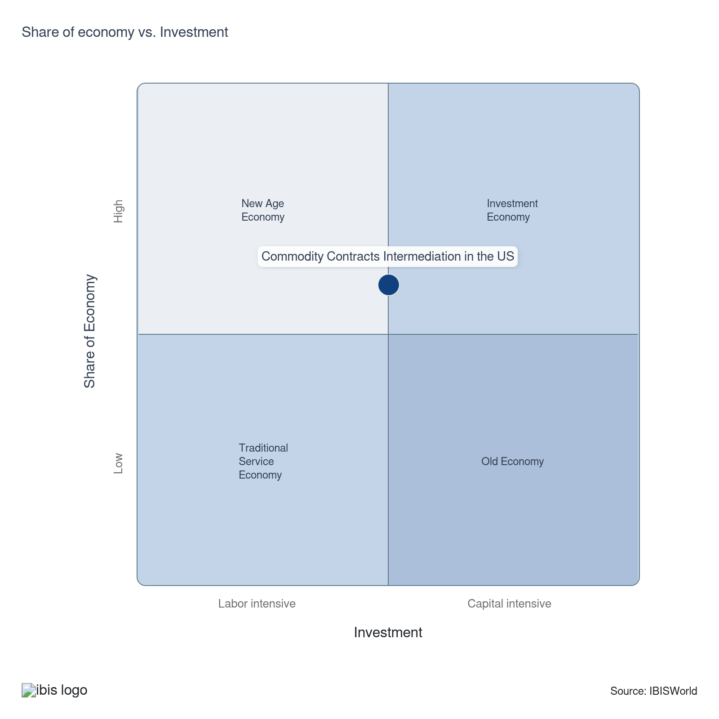

Financial Ratios

Earnings Ratios
Ratio | 2020 | 2021 | 2022 | 2023 | 2024 | 3-Year | 5-Year | 10-Year
EBIT/Revenue | 34.6 | 42.6 | 24.5 | 27.6 | 23.3 | 25.5 | 29.5 | 22.8
EBITDA/Revenue | 38.8 | 45.3 | 26.5 | 38.5 | 27.5 | 33.0 | 34.4 | 28.6
Leverage Ratio | 0.1 | 2.2 | 3.8 | 2.6 | 3.6 | 3.1 | 3.1 | 1.6

Industry Tax Structure
Ratio | 2020 | 2021 | 2022 | 2023 | 2024 | 3-Year | 5-Year | 10-Year
Taxes Paid/Revenue | 1.7 | 1.6 | 2.0 | 7.6 | 4.1 | 5.8 | 3.8 | 2.9

Income Statement
Ratio | 2020 | 2021 | 2022 | 2023 | 2024 | 3-Year | 5-Year | 10-Year
Total Revenue | 100.0 | 100.0 | 100.0 | 100.0 | 100.0 | 100.0 | 100.0 | 100.0
Business receipts | 97.3 | 84.2 | 66.7 | 79.1 | 179.6 | 129.4 | 102.4 | 96.7
Cost of goods | 0.0 | 0.0 | 0.0 | 0.0 | 0.0 | 0.0 | 0.0 | 0.0
Gross Profit | 100.0 | 100.0 | 100.0 | 100.0 | 100.0 | 100.0 | 100.0 | 100.0
Expenses
Salaries and wages | 17.9 | 16.9 | 14.8 | 18.5 | 13.1 | 15.8 | 15.8 | 19.0
Advertising | 1.0 | 1.3 | 0.8 | 3.4 | 2.6 | 3.0 | 2.0 | 1.5
Depreciation | 1.7 | 1.3 | 1.0 | 3.6 | 2.0 | 2.8 | 2.0 | 2.5
Depletion | 0.0 | 0.0 | 0.0 | 0.0 | 0.0 | 0.0 | 0.0 | 0.0
Amortization | 2.5 | 1.4 | 0.9 | 7.3 | 2.1 | 4.7 | 2.9 | 3.3
Rent paid | 8.6 | 5.5 | 0.5 | 3.4 | 2.1 | 2.8 | 2.9 | 5.1
Repairs | 0.2 | 0.2 | 0.3 | 4.5 | 1.4 | 3.0 | 1.6 | 0.9
Bad debts | 0.5 | 0.0 | 0.1 | 0.1 | 0.1 | 0.1 | 0.1 | 0.2
Employee benefit programs | 1.6 | 1.5 | 1.0 | 0.9 | 2.8 | 1.9 | 1.5 | 1.4
Compensation of officers | 1.5 | 1.7 | 1.6 | 1.2 | 8.3 | 4.8 | 3.2 | 3.6
Taxes paid | 1.7 | 1.6 | 2.0 | 7.6 | 4.1 | 5.8 | 3.8 | 2.9
Interest Income | 14.7 | 4.9 | 12.8 | 7.3 | -47.9 | -20.3 | -5.7 | 2.6
Other Income
Royalties | 0.0 | 0.0 | 0.0 | 2.0 | -12.9 | -5.5 | -2.7 | -1.2
Rent Income | 0.0 | 0.0 | 0.0 | 2.7 | -2.6 | 0.0 | 0.0 | 0.2
Net Income | 23.8 | 38.0 | 15.5 | 6.4 | 10.4 | 8.4 | 17.6 | 10.5
Charitable contributions | 0.0 | 0.1 | 0.0 | 0.1 | 0.0 | 0.1 | 0.1 | 0.0
Dividends | 0.0 | 0.0 | 0.0 | 0.0 | 0.0 | 0.0 | 0.0 | 0.1
Interest paid | 9.1 | 2.9 | 7.0 | 13.6 | 8.9 | 11.2 | 8.1 | 9.4
Net gain, noncapital assets | 0.0 | 0.0 | 20.0 | 1.6 | -1.6 | 0.0 | 5.0 | 2.4
Net long-term capital gain less net short-term loss | 0.0 | 0.0 | 0.2 | 4.8 | -12.4 | -3.8 | -1.8 | -0.8
Net loss, noncapital assets | 1.2 | 0.4 | 30.6 | 0.2 | 5.0 | 2.6 | 9.0 | 6.1
Net short-term capital gain less net long-term loss | 0.0 | 0.0 | 0.3 | 2.4 | -2.3 | 0.0 | 0.1 | 0.2
Other deductions | 28.4 | 27.1 | 23.6 | 28.5 | 35.1 | 31.8 | 28.6 | 32.9
Other receipts | -12.0 | 10.9 | 0.0 | 0.0 | 0.0 | 0.0 | 2.7 | -0.1
Pension, profit-sharing, etc., plans | 0.2 | 0.2 | 0.2 | 0.7 | 1.9 | 1.3 | 0.8 | 0.6

Balance Sheet
Ratio | 2020 | 2021 | 2022 | 2023 | 2024 | 3-Year | 5-Year | 10-Year
Assets
Cash and Equivalents | 9.8 | 35.4 | 25.5 | 13.6 | 11.2 | 12.4 | 21.4 | 17.5
Notes and accounts receivable | 10.7 | 11.4 | 26.2 | 19.5 | 32.7 | 26.1 | 22.4 | 16.9
Allowance for bad debts | 0.0 | 0.0 | 0.0 | 1.0 | 1.2 | 1.1 | 0.5 | 0.3
Inventories | 0.0 | 0.0 | 0.0 | 8.3 | 7.5 | 7.9 | 3.9 | 1.8
Other current assets | 24.4 | 36.0 | 20.4 | 13.1 | 13.1 | 13.1 | 20.7 | 26.0
Other investments | 43.2 | 10.8 | 19.8 | 2.6 | 7.9 | 5.3 | 10.3 | 21.7
Property, Plant and Equipment | 10.0 | 4.0 | 3.5 | 22.5 | 2.3 | 12.4 | 8.1 | 7.9
Accumulated depreciation | 1.9 | 1.0 | 1.1 | 1.1 | -2.1 | -0.5 | 0.3 | 1.4
Intangible assets (Amortizable) | 1.3 | 1.2 | 1.0 | 8.5 | 10.9 | 9.7 | 5.4 | 3.6
Accumulated amortization | 0.5 | 0.2 | 0.2 | 3.5 | 3.5 | 3.5 | 1.8 | 1.2
Other assets | 3.1 | 2.4 | 4.7 | 6.0 | 7.0 | 6.5 | 5.0 | 5.1
Total assets | 100.0 | 100.0 | 100.0 | 100.0 | 100.0 | 100.0 | 100.0 | 100.0
Accounts payable | 33.6 | 20.7 | 27.1 | 25.6 | 24.1 | 24.9 | 24.4 | 31.2
Liabilities and Net Worth
Mort, notes, and bonds under 1 yr | 5.8 | 3.3 | 2.4 | 8.5 | 7.6 | 8.1 | 5.5 | 8.4
Other current liabilities | 40.0 | 40.5 | 48.6 | 30.0 | 31.1 | 30.6 | 37.6 | 28.9
Loans from shareholders | 0.0 | 0.5 | 2.5 | 2.2 | 1.6 | 1.9 | 1.7 | 1.9
Mort, notes, bonds, 1 yr or more | 10.3 | 4.2 | 3.3 | 7.0 | 5.0 | 6.0 | 4.9 | 6.5
Other liabilities | 0.8 | 28.1 | 9.0 | 16.2 | 17.7 | 17.0 | 17.8 | 10.2
Total liabilities | 100.0 | 100.0 | 100.0 | 100.0 | 100.0 | 100.0 | 100.0 | 100.0
Capital stock | 1.2 | 0.5 | 0.9 | 4.4 | 2.7 | 3.6 | 2.1 | 5.2
Additional paid-in capital | 7.4 | 3.5 | 7.0 | 3.4 | 9.0 | 6.2 | 5.7 | 7.0
Retained earnings, appropriated | 0.0 | 0.0 | 0.0 | -3.5 | -2.5 | -3.0 | -1.5 | -0.3
Retained earnings-unappropriated | 0.9 | -1.4 | -0.9 | 12.6 | 9.0 | 10.8 | 4.8 | 2.6
Cost of treasury stock | 0.0 | 0.0 | 0.0 | 6.4 | 5.3 | 5.8 | 2.9 | 1.5
Net worth | 9.6 | 2.6 | 6.9 | 10.6 | 12.8 | 11.7 | 8.2 | 12.9
Accumulated depletion | 0.0 | 0.0 | 0.0 | 1.8 | 1.7 | 1.8 | 0.9 | 0.4
Depletable assets | 0.0 | 0.0 | 0.0 | 6.4 | 5.4 | 5.9 | 3.0 | 1.3
Government Obligations | 0.0 | 0.0 | 0.0 | 2.3 | 2.5 | 2.4 | 1.2 | 0.5
Land | 0.0 | 0.0 | 0.0 | 1.3 | 1.4 | 1.4 | 0.7 | 0.3
Loans to shareholders | 0.0 | 0.0 | 0.1 | 1.2 | 0.6 | 0.9 | 0.5 | 0.2
Mortgage and real estate loans | 0.0 | 0.0 | 0.0 | 0.4 | 0.5 | 0.5 | 0.2 | 0.1
Tax Exempt Securities | 0.0 | 0.0 | 0.0 | 1.6 | 1.4 | 1.5 | 0.7 | 0.3

Liquidity Ratios
Ratio | 2020 | 2021 | 2022 | 2023 | 2024 | 3-Year | 5-Year | 10-Year
Current Ratio | 0.6 | 1.3 | 0.9 | 0.9 | 1.1 | 1.0 | 1.1 | 0.9
Quick Ratio | 0.6 | 1.3 | 0.9 | 0.8 | 1.0 | 0.9 | 1.0 | 0.9
Sales/Receivables | 9.3 | 8.8 | 3.8 | 5.1 | 3.1 | 4.1 | 5.2 | 6.9
Days' Receivables | 39.1 | 41.5 | 95.6 | 71.2 | 119.3 | 95.2 | 81.9 | 61.7
Days' Inventory | N/A | N/A | N/A | N/A | N/A | N/A | N/A | N/A
Inventory Turnover | N/A | N/A | N/A | 0.0 | 0.0 | 0.0 | 0.0 | 0.0
Payables Turnover | 0.0 | 0.0 | 0.0 | 0.0 | 0.0 | 0.0 | 0.0 | 0.0
Days' Payables | N/A | N/A | N/A | N/A | N/A | N/A | N/A | N/A
Sales/Working Capital | 5.5 | 4.6 | -11.0 | -17.0 | 27.2 | 5.1 | 1.0 | 2.7

Coverage Ratios
Ratio | 2020 | 2021 | 2022 | 2023 | 2024 | 3-Year | 5-Year | 10-Year
Interest Coverage | 3.8 | 14.5 | 3.5 | 2.0 | 2.6 | 2.3 | 5.7 | 3.5
Debt Service Coverage Ratio | 1.1 | 0.1 | 0.1 | 0.1 | 0.1 | 0.1 | 0.1 | 0.2

Leverage Ratios
Ratio | 2020 | 2021 | 2022 | 2023 | 2024 | 3-Year | 5-Year | 10-Year
Fixed Assets/Net Worth | 1.4 | 2.5 | 0.9 | 4.3 | 1.8 | 3.0 | 2.3 | 1.5
Debt/Net Worth | 10.5 | 38.0 | 14.4 | 9.5 | 7.8 | 8.6 | 17.4 | 11.4
Tangible Net Worth | 9.6 | 2.6 | 6.9 | 10.6 | 12.8 | 11.7 | 8.2 | 12.9

Operating Ratios
Ratio | 2020 | 2021 | 2022 | 2023 | 2024 | 3-Year | 5-Year | 10-Year
Return on Net Worth, % | 6627.3 | 1620.1 | 353.8 | 261.4 | 181.6 | 221.5 | 604.2 | 1322.4
Return on Assets, % | 34.6 | 42.6 | 24.5 | 27.6 | 23.3 | 25.5 | 29.5 | 22.8
Sales/Total Assets | 1.0 | 1.0 | 1.0 | 1.0 | 1.0 | 1.0 | 1.0 | 1.0
EBITDA/Revenue | 38.8 | 45.3 | 26.5 | 38.5 | 27.5 | 33.0 | 34.4 | 28.6
EBIT/Revenue | 34.6 | 42.6 | 24.5 | 27.6 | 23.3 | 25.5 | 29.5 | 22.8

Cash Flow & Debt Service Ratios (% of sales)
Ratio | 2020 | 2021 | 2022 | 2023 | 2024 | 3-Year | 5-Year | 10-Year
Cash from Trading | 105.1 | -12.4 | 108.4 | 86.5 | 115.6 | 101.0 | 74.5 | 87.9
Cash after Operations | 77.4 | -43.4 | 114.1 | 44.1 | 89.2 | 66.7 | 51.0 | 58.8
Net Cash after Operations | 68.6 | -62.0 | 98.1 | 61.5 | 140.8 | 101.1 | 59.6 | 62.0
Debt Service P&I Coverage | 3.8 | -5.3 | 9.9 | 2.4 | 7.5 | 5.0 | 3.6 | 3.7
Interest Coverage (Operating Cash) | 7.5 | -21.1 | 14.1 | 4.5 | 15.8 | 10.2 | 3.3 | 5.1

Valuation Multiples

Valuation Multiples
Ratio | 2020 | 2021 | 2022 | 2023 | 2024 | 3-Year | 5-Year | 10-Year
EV/Revenue | 0.2 | -0.3 | -0.1 | 0.2 | 0.1 | 0.1 | 0.0 | 0.1
EV/EBITDA | 0.2 | -0.3 | -0.2 | 0.2 | 0.2 | 0.1 | 0.0 | 0.5
EV/EBIT | 0.2 | -0.3 | -0.2 | 0.3 | 0.2 | 0.1 | 0.0 | -0.4

Key Ratios
Year | Revenue per Employee  ($) | Revenue per Enterprise  ($ Million) | Employees per Estab.  (Units) | Employees per Enterprise  (Units) | Average Wage  ($) | Wages/ Revenue  (%) | Estab. per Enterprise  (Units) | IVA/ Revenue  (%)
2003 | 462,909 | 1.7 | 3.5 | 3.6 | 144,694 | 31.3 | 1.0 | 56.0
2004 | 437,741 | 1.8 | 3.9 | 4.1 | 161,958 | 37.0 | 1.0 | 65.7
2005 | 541,617 | 2.0 | 3.6 | 3.7 | 152,627 | 28.2 | 1.0 | 49.5
2006 | 668,042 | 2.4 | 3.4 | 3.5 | 158,808 | 23.8 | 1.0 | 48.4
2007 | 749,789 | 2.9 | 3.6 | 3.8 | 207,113 | 27.6 | 1.1 | 49.9
2008 | 771,405 | 3.1 | 3.8 | 4.0 | 232,355 | 30.1 | 1.0 | 48.6
2009 | 719,857 | 2.9 | 3.9 | 4.1 | 209,866 | 29.2 | 1.0 | 50.7
2010 | 794,853 | 3.3 | 3.9 | 4.1 | 214,571 | 27.0 | 1.0 | 44.8
2011 | 839,700 | 3.5 | 4.0 | 4.1 | 228,942 | 27.3 | 1.0 | 41.6
2012 | 694,798 | 3.0 | 4.1 | 4.3 | 226,983 | 32.7 | 1.1 | 49.5
2013 | 842,346 | 3.4 | 3.8 | 4.0 | 184,978 | 22.0 | 1.1 | 36.1
2014 | 918,067 | 3.7 | 3.8 | 4.0 | 190,826 | 20.8 | 1.1 | 35.7
2015 | 965,260 | 3.8 | 3.7 | 3.9 | 194,063 | 20.1 | 1.1 | 33.5
2016 | 934,196 | 3.8 | 3.8 | 4.0 | 198,296 | 21.2 | 1.1 | 34.7
2017 | 833,490 | 3.7 | 4.1 | 4.4 | 210,723 | 25.3 | 1.1 | 36.4
2018 | 824,318 | 3.2 | 3.7 | 3.9 | 194,943 | 23.6 | 1.1 | 34.0
2019 | 901,378 | 3.7 | 3.8 | 4.1 | 201,176 | 22.3 | 1.1 | 35.1
2020 | 958,877 | 3.9 | 3.8 | 4.0 | 225,713 | 23.5 | 1.1 | 38.6
2021 | 900,191 | 2.5 | 2.6 | 2.7 | 222,537 | 24.7 | 1.0 | 35.2
2022 | 1,063,911 | 4.2 | 3.7 | 4.0 | 310,675 | 29.2 | 1.1 | 37.1
2023 | 815,136 | 3.9 | 4.5 | 4.8 | 299,273 | 36.7 | 1.1 | 44.1
2024 | 797,500 | 3.7 | 4.4 | 4.7 | 297,987 | 37.4 | 1.1 | 44.7
2025 | 783,869 | 3.6 | 4.3 | 4.6 | 296,968 | 37.9 | 1.1 | 45.6
2026 | 785,485 | 3.6 | 4.3 | 4.6 | 297,081 | 37.8 | 1.1 | 45.2
2027 | 758,491 | 3.3 | 4.2 | 4.4 | 295,042 | 38.9 | 1.0 | 46.7
2028 | 748,963 | 3.2 | 4.1 | 4.3 | 294,296 | 39.3 | 1.0 | 47.1
2029 | 749,720 | 3.3 | 4.2 | 4.4 | 294,354 | 39.3 | 1.0 | 47.0
2030 | 744,785 | 3.3 | 4.2 | 4.4 | 293,969 | 39.5 | 1.0 | 47.2
2031 | 743,593 | 3.3 | 4.2 | 4.4 | 293,876 | 39.5 | 1.0 | 47.3
2032 | 732,524 | 3.2 | 4.1 | 4.3 | 293,001 | 40.0 | 1.0 | 47.6
*Figures are inflation adjusted to 2026
*Figures are inflation adjusted to 2026

10. Key Statistics
https://my.ibisworld.com/us/en/industry/52316/key-statistics

Industry Data

Values
Year | Revenue  ($ Million) | IVA  ($ Million) | Estab.  (Units) | Enterprises  (Units) | Employment  (Units) | Wages  ($ Million)
2003 | 12,061.1 | 6,753.9 | 7,427 | 7,139 | 26,055 | 3,770.0
2004 | 12,781.6 | 8,398.4 | 7,529 | 7,193 | 29,199 | 4,729.0
2005 | 14,561.4 | 7,203.6 | 7,457 | 7,197 | 26,885 | 4,103.4
2006 | 17,226.8 | 8,333.0 | 7,599 | 7,308 | 25,787 | 4,095.2
2007 | 20,355.3 | 10,151.8 | 7,494 | 7,135 | 27,148 | 5,622.7
2008 | 20,134.4 | 9,779.5 | 6,794 | 6,499 | 26,101 | 6,064.7
2009 | 18,001.5 | 9,127.4 | 6,458 | 6,169 | 25,007 | 5,248.1
2010 | 19,919.0 | 8,932.7 | 6,383 | 6,086 | 25,060 | 5,377.1
2011 | 20,309.0 | 8,441.5 | 6,119 | 5,834 | 24,186 | 5,537.2
2012 | 17,716.6 | 8,764.3 | 6,266 | 5,870 | 25,499 | 5,787.8
2013 | 17,808.0 | 6,428.8 | 5,584 | 5,294 | 21,141 | 3,910.6
2014 | 18,908.5 | 6,758.6 | 5,437 | 5,137 | 20,596 | 3,930.3
2015 | 18,659.4 | 6,259.3 | 5,272 | 4,945 | 19,331 | 3,751.4
2016 | 17,541.4 | 6,087.6 | 4,965 | 4,647 | 18,777 | 3,723.4
2017 | 17,143.2 | 6,247.9 | 4,971 | 4,631 | 20,568 | 4,334.2
2018 | 17,739.3 | 6,028.7 | 5,890 | 5,555 | 21,520 | 4,195.2
2019 | 18,145.6 | 6,368.0 | 5,240 | 4,914 | 20,131 | 4,049.9
2020 | 19,702.0 | 7,612.5 | 5,430 | 5,099 | 20,547 | 4,637.7
2021 | 21,426.4 | 7,548.1 | 9,044 | 8,725 | 23,802 | 5,296.8
2022 | 22,809.2 | 8,458.7 | 5,764 | 5,420 | 21,439 | 6,660.6
2023 | 21,582.4 | 9,512.8 | 5,833 | 5,509 | 26,477 | 7,923.9
2024 | 21,353.1 | 9,537.5 | 6,022 | 5,706 | 26,775 | 7,978.6
2025 | 21,307.1 | 9,714.2 | 6,253 | 5,944 | 27,182 | 8,072.2
2026 | 22,333.7 | 10,094.6 | 6,540 | 6,220 | 28,433 | 8,446.9
2027 | 21,296.9 | 9,943.8 | 6,681 | 6,385 | 28,078 | 8,284.2
2028 | 21,627.8 | 10,177.4 | 6,982 | 6,690 | 28,877 | 8,498.4
2029 | 21,936.8 | 10,317.0 | 6,922 | 6,622 | 29,260 | 8,612.8
2030 | 22,352.5 | 10,557.7 | 7,085 | 6,782 | 30,012 | 8,822.6
2031 | 22,729.4 | 10,747.6 | 7,253 | 6,948 | 30,567 | 8,982.9
2032 | 22,186.7 | 10,563.4 | 7,302 | 7,009 | 30,288 | 8,874.4

*Figures are inflation adjusted to 2026

Annual Change
Year | Revenue  % | IVA  % | Estab.  % | Enterprises  % | Employment  % | Wages  %
2003 | N/A | N/A | N/A | N/A | N/A | N/A
2004 | 6.0 | 24.3 | 1.4 | 0.8 | 12.1 | 25.4
2005 | 13.9 | -14.2 | -1.0 | 0.1 | -7.9 | -13.2
2006 | 18.3 | 15.7 | 1.9 | 1.5 | -4.1 | -0.2
2007 | 18.2 | 21.8 | -1.4 | -2.4 | 5.3 | 37.3
2008 | -1.1 | -3.7 | -9.3 | -8.9 | -3.9 | 7.9
2009 | -10.6 | -6.7 | -4.9 | -5.1 | -4.2 | -13.5
2010 | 10.7 | -2.1 | -1.2 | -1.3 | 0.2 | 2.5
2011 | 2.0 | -5.5 | -4.1 | -4.1 | -3.5 | 3.0
2012 | -12.8 | 3.8 | 2.4 | 0.6 | 5.4 | 4.5
2013 | 0.5 | -26.6 | -10.9 | -9.8 | -17.1 | -32.4
2014 | 6.2 | 5.1 | -2.6 | -3.0 | -2.6 | 0.5
2015 | -1.3 | -7.4 | -3.0 | -3.7 | -6.1 | -4.5
2016 | -6.0 | -2.7 | -5.8 | -6.0 | -2.9 | -0.7
2017 | -2.3 | 2.6 | 0.1 | -0.3 | 9.5 | 16.4
2018 | 3.5 | -3.5 | 18.5 | 20.0 | 4.6 | -3.2
2019 | 2.3 | 5.6 | -11.0 | -11.5 | -6.5 | -3.5
2020 | 8.6 | 19.5 | 3.6 | 3.8 | 2.1 | 14.5
2021 | 8.8 | -0.8 | 66.6 | 71.1 | 15.8 | 14.2
2022 | 6.5 | 12.1 | -36.3 | -37.9 | -9.9 | 25.7
2023 | -5.4 | 12.5 | 1.2 | 1.6 | 23.5 | 19.0
2024 | -1.1 | 0.3 | 3.2 | 3.6 | 1.1 | 0.7
2025 | -0.2 | 1.9 | 3.8 | 4.2 | 1.5 | 1.2
2026 | 4.8 | 3.9 | 4.6 | 4.6 | 4.6 | 4.6
2027 | -4.6 | -1.5 | 2.2 | 2.7 | -1.2 | -1.9
2028 | 1.6 | 2.3 | 4.5 | 4.8 | 2.8 | 2.6
2029 | 1.4 | 1.4 | -0.9 | -1.0 | 1.3 | 1.3
2030 | 1.9 | 2.3 | 2.4 | 2.4 | 2.6 | 2.4
2031 | 1.7 | 1.8 | 2.4 | 2.4 | 1.8 | 1.8
2032 | -2.4 | -1.7 | 0.7 | 0.9 | -0.9 | -1.2

*Figures are inflation adjusted to 2026

DISCLAIMER
This product has been supplied by IBISWorld Inc. (‘IBISWorld’) solely for use by its authorized licenses strictly in accordance with their license agreements with IBISWorld. IBISWorld makes no representation to any other person with regard to the completeness or accuracy of the data or information contained herein, and it accepts no responsibility and disclaims all liability (save for liability which cannot be lawfully disclaimed) for loss or damage whatsoever suffered or incurred by any other person resulting from the use of, or reliance upon, the data or information contained herein. Copyright in this publication is owned by IBISWorld Inc. The publication is sold on the basis that the purchaser agrees not to copy the material contained within it for other than the purchasers own purposes. In the event that the purchaser uses or quotes from the material in this publication – in papers, reports, or opinions prepared for any other person – it is agreed that it will be sourced to: IBISWorld Inc.

